Contents

SUBROUTINE CALLS 2

ACCESSING STACK PARAMETERS 24

BASE OFFSET ADDRESSING 33

EXPLICIT STACK PARAMETERS 36

CLEANING UP THE STACK 39

STACK CORRUPTION VS STACK OVERFLOW 43

CALLING CONVENTIONS 45

SAVING AND RESTORING REGISTERS 49

LOCAL VARIABLES IN ASSEMBLY 53

LOCAL VARIABLE SYMBOLS IN ASSEMBLY 56

REFERENCE PARAMETERS 58

LEA INSTRUCTION AND STACK PARAMETERS 61

ENTER AND LEAVE INSTRUCTIONS 65

LOCAL DIRECTIVE 68

RECURSION IN ASSEMBLY LANGUAGE 75

INVOKE, ADDR, PROC AND PROTO 87

ASSEMBLY TIME ARGUMENT CHECKING 97

WIRESTACKFRAME PROCEDURE 108

MULTIMODULE PROGRAMS 112

CALLING EXTERNAL PROCEDURES 115

ADVANCED OPTIONAL TOPIC 1 – USES OPERATOR 138

PASSING 8-BIT AND 16-BIT ARGUMENTS ON THE STACK 140

SUBROUTINE CALLS

Introduction to Subroutine Calls

This chapter covers the fundamental structure of subroutine calls, with a focus on the runtime stack. Subroutine calls are common in C and C++ programming, and debugging these calls can require an understanding of the runtime stack.

In C and C++, subroutines are referred to as **functions**, while in Java, they are known as **methods.** In MASM, they are termed **procedures.**

Values passed to a subroutine by a calling program are termed arguments. However, once these values are received by the called **subroutine**, they become **parameters**.

**Stack frames** are used to manage subroutine calls. A **stack frame** is a region of memory on the runtime stack that is used to store the subroutine's local variables and parameters.

* Subroutine calls are a fundamental part of low-level programming.
* The runtime stack is used to manage subroutine calls.
* **Arguments** passed to a subroutine **become parameters** within the subroutine.
* Stack frames are used to store local variables and parameters for subroutines.

Stack Frames

In this section, we'll delve into the concept of stack frames, specifically focusing on stack parameters.

I. Stack Parameters

In 32-bit mode, stack parameters are the norm for Windows API functions.

In 64-bit mode, Windows functions receive a combination of both register and stack parameters.

To pass a parameter to a subroutine on the stack, the **caller function pushes** the parameter onto the stack before calling the subroutine.

The subroutine then accesses the parameter by using the stack pointer register.

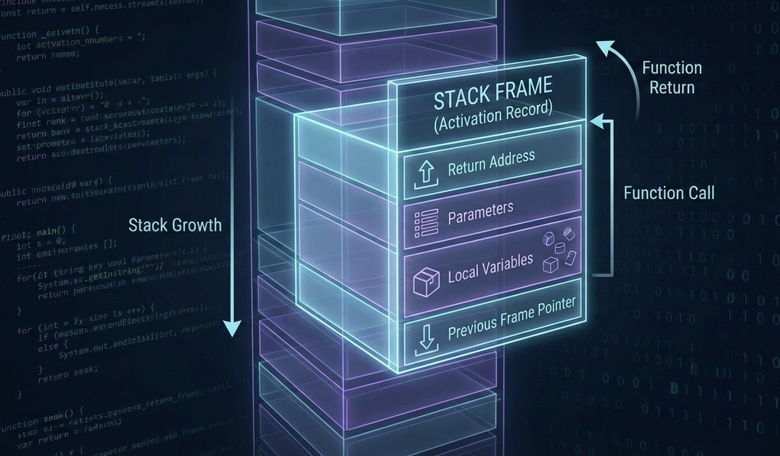

II. The Anatomy of a Stack Frame

A **stack frame** (also called an **activation record**) is a specific chunk of memory created on the stack every time a function (subroutine) is called.  
Think of it as the function’s **personal workspace** while it’s running.

This stack frame holds:

* Arguments passed to the function
* The return address (where execution should go after the function finishes)
* Local variables
* Saved registers

III. How a Stack Frame Is Built (Step by Step)

1. **Passed arguments** (if any) are pushed onto the stack first.
2. When the subroutine starts executing, the current value of the **Extended Base Pointer (EBP)** is pushed onto the stack.  
   This preserves the caller’s stack frame.
3. The **EBP is then set equal to the current Stack Pointer (ESP)**.  
   From this point on, EBP becomes a **stable reference point** for accessing:
   * Function parameters
   * Local variables
4. If the subroutine uses **local variables**, the **Stack Pointer (ESP) is decremented** to reserve space for them on the stack.

IV. Important Stack Behavior to Remember

* The stack starts at **higher memory addresses**.
* As values are pushed, **ESP decreases** → the stack **grows downward**.
* When values are popped, **ESP increases**.

This downward growth explains why space for parameters and local variables is allocated by decrementing the stack pointer.

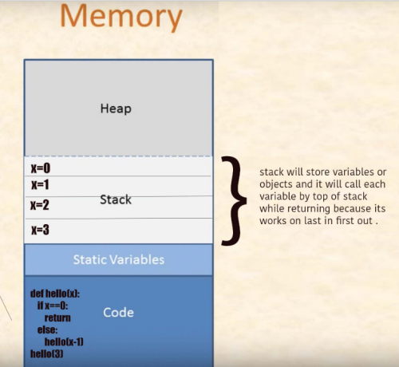

If certain **registers need to be preserved**, they are pushed onto the stack before the subroutine modifies them. This ensures their original values can be restored before returning control to the caller.

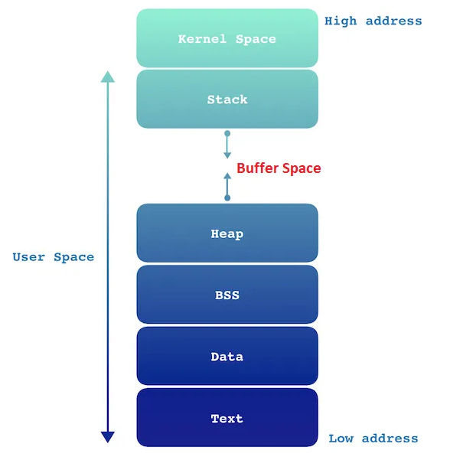

The **layout and organization of a stack frame** depend heavily on:

* The program’s **memory model**
* The **calling convention** used to pass arguments

**Why Argument Passing on the Stack Matters**

Understanding how arguments are passed on the stack is **crucial**, because most high-level programming languages rely on this mechanism.

For example:

* In **32-bit Windows API programming**, function arguments are typically passed **on the stack**.
* In **64-bit programming**, a different calling convention is used (many arguments are passed through registers instead).  
  We’ll explore this newer convention in detail in later chapters.

**Calls and the Stack (MASM Example)**

Consider a scenario where **“Reese”** (the calling, external procedure) calls **“Rennex”** (the called, internal procedure) in MASM.

Here’s what actually happens:

* When **Reese calls Rennex**, it is **Reese** that pushes **Rennex’s return address** onto the stack.
* This return address points to the exact instruction in **Reese** where execution should continue after **Rennex** finishes.
* In other words, **the caller (Reese)** is responsible for saving the return address.

**During Execution**

* **Rennex** runs its code normally.
* When Rennex reaches the RET instruction, it **uses the saved return address** to transfer control back to Reese.

**After the Return**

* Control returns to **Reese**.
* At this point, it is typically **Reese’s responsibility to clean up the stack**.
* Reese issues a **POP instruction** to remove the return address from the stack.
* This POP:
  + Retrieves the value at the top of the stack
  + Adjusts the **Stack Pointer (ESP)** accordingly

By doing this, Reese ensures:

* The stack remains balanced
* Program flow continues correctly

**About Stack Diagrams**

Some stack diagrams can look confusing at first, especially when multiple values are involved.  
However, the rule **never changes**:

The stack pointer **always points to the top of the stack**.

Even when the diagram looks complex, the underlying behavior of the stack remains the same.

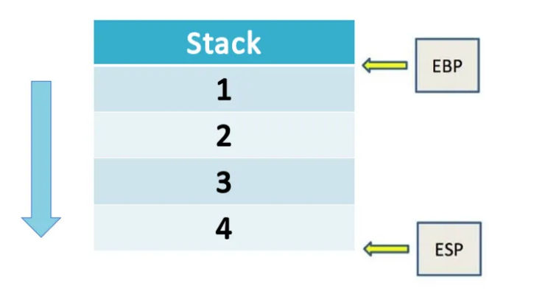

Right now, the stack pointer (ESP) is pointing at the very top of the current stack frame, and the value sitting there is 4.

The extended base pointer (EBP) is pointing lower down, at the bottom of this stack frame, where the value 1 lives.

At first glance this can feel a little backwards — because we usually think of memory addresses getting bigger as we go “up.” But here’s the key thing to remember:

The stack grows downward in memory.

That means every time you push something new onto the stack, it gets placed at a lower memory address than whatever was there before.

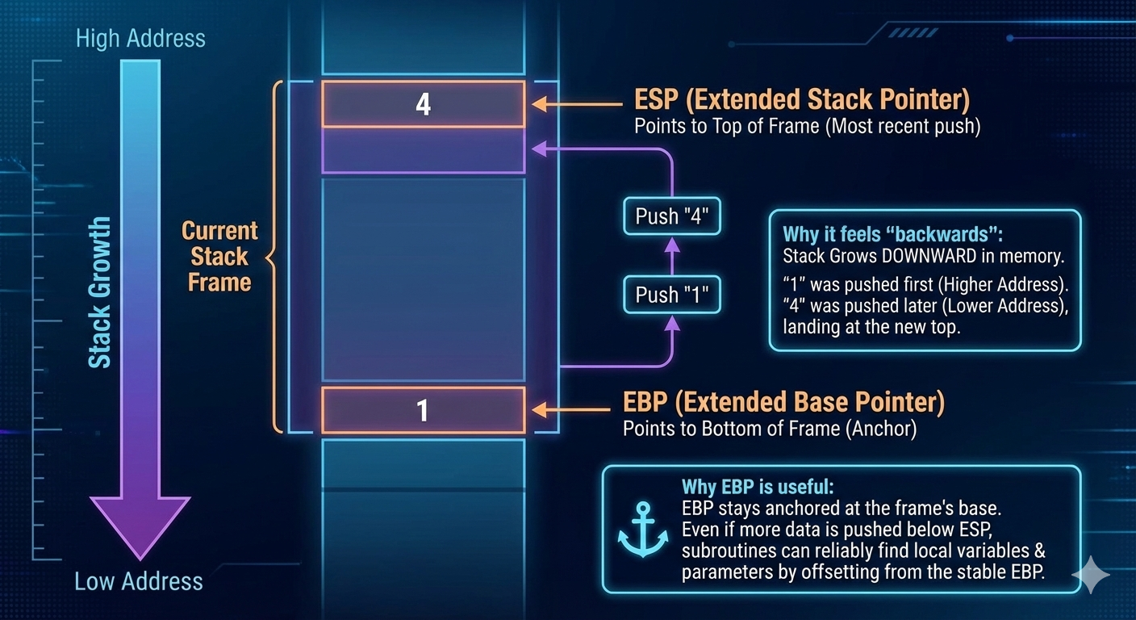

So, in the picture you’re looking at:

* First, the value 1 was pushed → it landed at a higher memory address
* Then the value 4 was pushed → it landed at a lower memory address

That’s why 1 ends up at the bottom of the stack frame, and 4 ends up at the top (even though 4 is the most recently added item).

And that’s exactly why we have EBP (the base pointer).

It stays parked at the bottom of the current stack frame — kind of like an anchor.

That way, even if the function you’re currently in pushes more stuff onto the stack later, your subroutine can still reliably find its own local variables and parameters by counting offsets from EBP. Super handy!

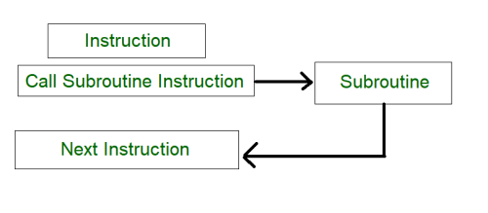

Stack Frames and Subroutine Calls

When a subroutine is called, the **EBP register** plays a central role in creating a stack frame:

1. **Setup:**
   * The current value of EBP is pushed onto the stack.
   * EBP is then set equal to ESP, marking the start of the new frame.
2. **Accessing variables:**
   * Local variables are accessed using negative offsets from EBP.
     + First local variable → [EBP-4]
     + Second local variable → [EBP-8]
     + And so on.
   * Parameters are accessed using positive offsets from EBP.
3. **Return:**
   * When the subroutine ends, the saved EBP is popped back from the stack.
   * This restores the previous stack frame, returning control cleanly to the caller.

Disadvantages of Register Parameters (Fastcall Convention)

Passing arguments in registers can be faster than using the stack, but it comes with trade‑offs:

* **Registers are multi‑purpose:**
  + The same registers used for parameters are also needed for loop counters, operands, and other tasks.
  + This means they often must be saved (pushed) before use and restored (popped) afterward.
* **Code clutter:**
  + Extra pushes and pops make the code harder to read and maintain.
* **Error risk:**
  + Every PUSH must be matched with a POP.
  + If execution paths diverge (e.g., multiple branches), it’s easy to mismatch pushes/pops, leaving registers stuck on the stack and causing unpredictable behavior.

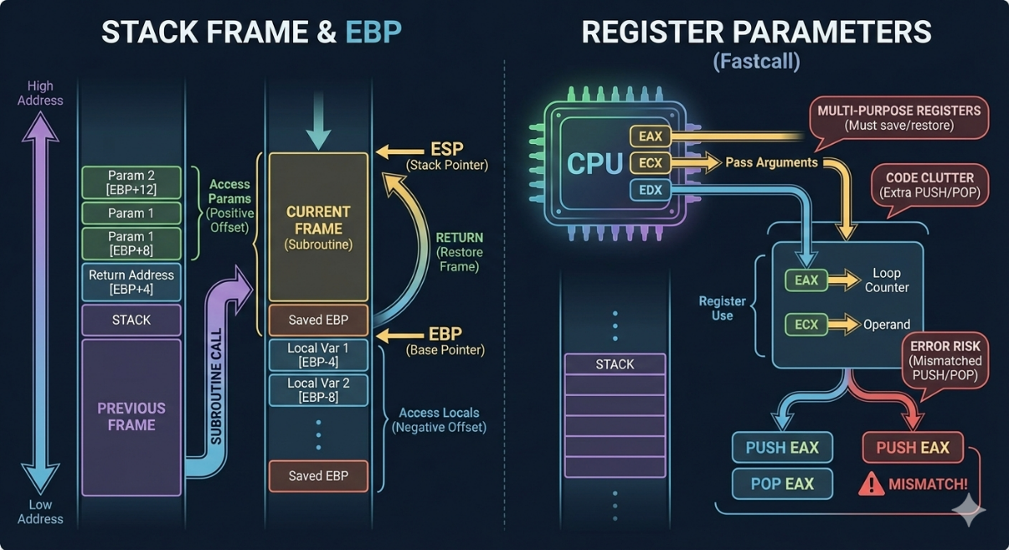

The following code shows an example of how register parameters can be used to call the DumpMem subroutine from the Irvine32 library:

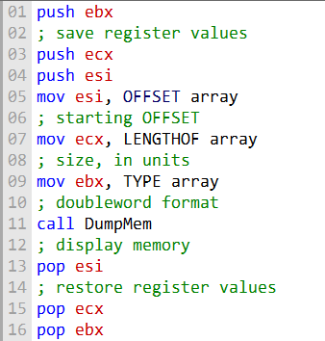

Saving and Restoring Registers with the Stack

When working with subroutines, registers often need to be preserved. This is done by **pushing** them onto the stack before the call and **popping** them back afterward. Because the stack operates in **LIFO (Last In, First Out)** order, the registers must be popped in the reverse order they were pushed.

Example Flow

1. **Before the call:**
   * EAX, EBX, and ECX are pushed onto the stack.
   * This saves their values so the subroutine can safely use them.
2. **Inside the subroutine (**DumpMem**):**
   * The registers are used to access and display memory.
3. **After the call:**
   * The saved values are popped back into EAX, EBX, and ECX.
   * This restores the original state of the registers.

Potential Pitfall

If the push/pop sequence is mismatched, the stack becomes unbalanced. For example:

* If EAX = 1 at line 8 and the procedure exits incorrectly, three register values remain on the stack.
* This prevents the procedure from returning properly at line 17, since the return address is buried under leftover data.

Key Takeaway

Always respect the **push/pop balance**. Every register pushed must be popped in reverse order, or the stack frame will break — leading to errors like failed returns or corrupted data.



Stack Parameters: The Nicer Way to Pass Arguments

When you want to send info (arguments) to a subroutine, using the stack is actually one of the cleanest and most flexible methods out there. The idea is super straightforward:

1. Before you call the subroutine, just push each argument you want to send onto the stack.
2. Then call the subroutine like normal.
3. Inside the subroutine, it can reach back and grab those values right off the stack.

That’s it! No weird registers to juggle, no fixed limits on how many arguments you can pass — the stack just grows to hold whatever you need. Here’s a quick real-world feel for it: Imagine you want to call a subroutine called DumpMem that needs three pieces of info:

* A starting memory address
* A length (how many bytes to dump)
* Maybe a flag or format option

Instead of cramming everything into registers (which can get messy fast), you’d do something like this in assembly:

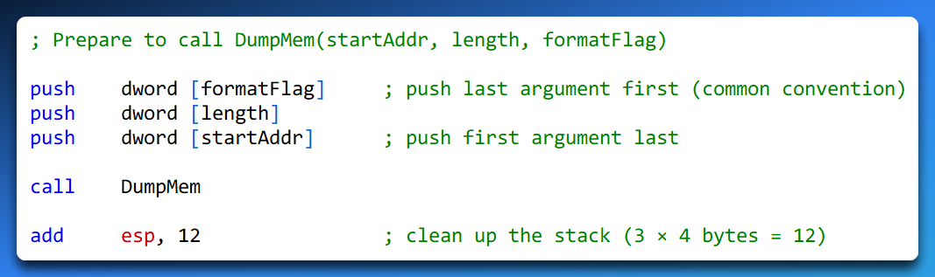

(The exact push order and cleanup style can vary depending on the calling convention, but the core idea stays the same.)

Pushing arguments onto the stack before the call means:

* The subroutine can easily find them relative to the EBP (base pointer) once it sets up its own stack frame
* You can pass as many arguments as you want (limited only by available stack space)
* It’s very reliable — especially useful in nested calls or when you have lots of parameters

It’s one of those things that feels a little “extra” at first, but once you get used to it, it becomes super natural and way less error-prone than trying to squeeze everything into registers.

I. Advantages of Stack Parameters

Stack parameters have a number of advantages over register parameters:

**More flexible**. Stack parameters can be used to pass any number of arguments to a subroutine, regardless of the number of registers available.



**More reliable.** Stack parameters are less susceptible to errors than register parameters. For example, there is no need to worry about matching every PUSH with a POP.



**Easier to maintain.** Code that uses stack parameters is typically easier to read and maintain than code that uses register parameters.



Stack parameters are the preferred way to pass arguments to subroutines in most cases. They offer a more flexible, reliable, and maintainable approach than register parameters.

Pass by Value

Let’s look at a super common way to pass arguments to a subroutine in MASM: passing by value using the stack.

When you pass something by value, you’re not sending the original variable — you’re pushing a copy of its value onto the stack.

Here’s the little MASM snippet we’re working with:

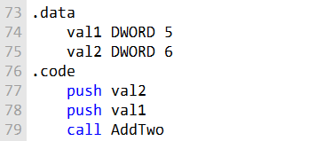

After the push instructions have been executed, the stack will look like this:

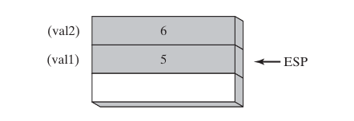

Notice something important:

* We pushed val2 (6) first
* Then we pushed val1 (5) second

Because the stack grows downward in memory (lower addresses), every new push makes ESP move to a lower address.

So, after both pushes:

* ESP is pointing at the most recently pushed value → val1 (5)
* val2 (6) is sitting just below it

This reverse-order pushing is the standard MASM / stdcall / Win32 calling convention trick.

It means the last argument you want the function to see gets pushed first.In C++ land, this code is basically doing the same thing as:

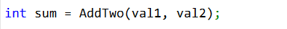

So, inside the AddTwo subroutine, once it sets up its stack frame (usually with push ebp; mov ebp, esp), the arguments are super easy to reach:

* At [ebp + 8] → first argument (val1 = 5)
* At [ebp + 12] → second argument (val2 = 6)

(Why +8 and +12? Because [ebp] holds the old EBP, [ebp+4] holds the return address, so arguments start at +8.)

When AddTwo is done and wants to clean up, it pops those two arguments off the stack (or more commonly, the caller cleans up by doing add esp, 8 after the call).

Either way, ESP gets bumped back up by 8 bytes (4 bytes × 2 arguments), so it points to whatever was on the stack before we started pushing.Quick recap of why this feels “backwards” at first:

* Stack grows down → new pushes → lower addresses → ESP moves down
* We push arguments right-to-left (last arg first) → so the first arg ends up closest to ESP
* ESP always points to the top (most recent) item

Pass by Reference

I. Passing Arguments by Reference in MASM -   
(“Let the Function Change My Stuff”)

Sometimes you don’t just want to hand a subroutine a copy of your value — you want it to be able to actually change the original variable back in your main code.

That’s when you pass by reference.

Instead of pushing the value itself onto the stack, you push the memory address (the location) of the variable.

Then inside the subroutine, it can go to that address and read or write whatever it wants — so changes stick around even after the subroutine finishes.

Here’s what that looks like in MASM (just the calling part for now):

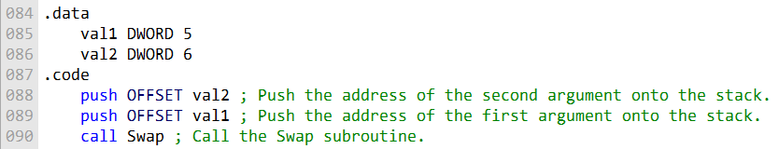

OR

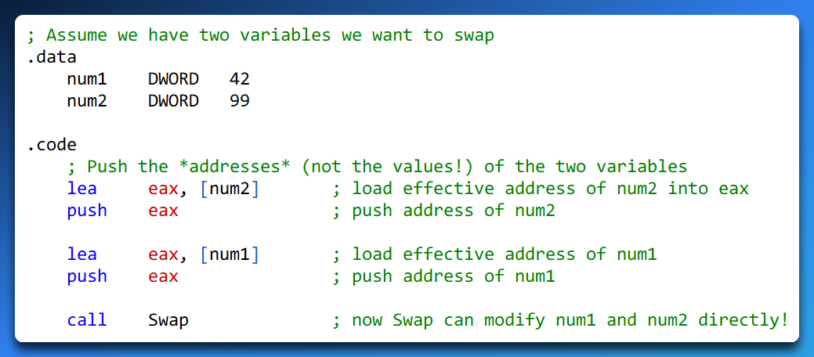

After the push instructions have been executed, the stack will look like this:

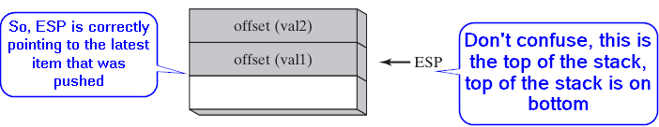

After those pushes, the stack has the addresses sitting on it (not 42 and 99, but something like 00403000h and 00403004h — whatever memory locations hold num1 and num2).

Inside the Swap subroutine, it would do something like this (super simplified):

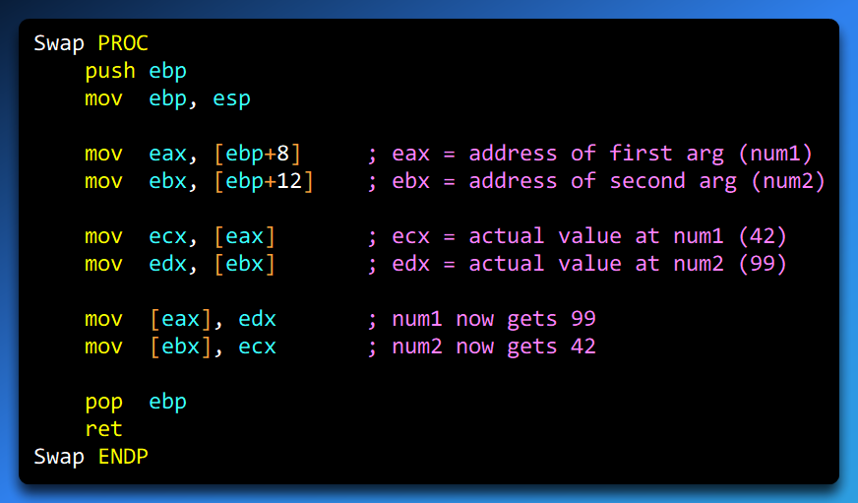

Key differences from pass-by-value:

1. We push addresses (using lea or offset) instead of values
2. The subroutine uses those addresses to dereference (go get or set the real data).  
   It’s basically like passing a pointer in C/C++:
3. Any changes the subroutine makes affect the original variables — magic!

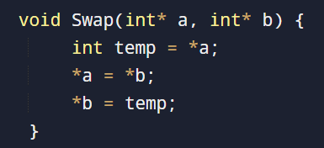

Super useful when you want the subroutine to return multiple results, update big structures, or just modify variables without copying them.

Stack Grows Downwards!!! (Yes, We’re Repeating It Because It’s Important)

Okay, let’s pick up right where we left off with passing by reference in that Swap example.

After pushing the addresses of num1 and num2 onto the stack (remember: we pushed the address of the second one first, then the first one — classic reverse order), the stack ends up looking something like this:



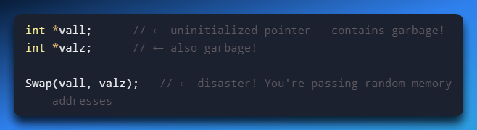

Why this is dangerous:

* vall and valz are pointers, but you never told them where to point.
* They’re holding junk values (whatever random bits were in memory).
* When Swap tries to use those junk addresses (*a = ...), it’s writing to random places in memory → crashes, corrupted data, undefined behavior, etc.
* Never pass uninitialized pointers!

Correct way (this actually works):

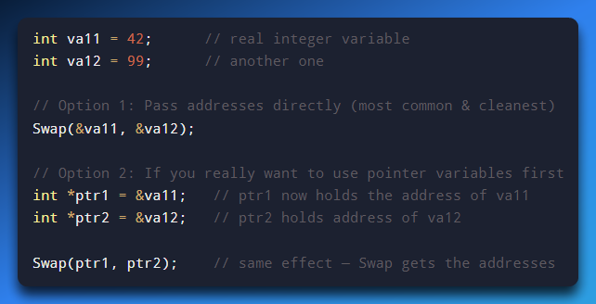

Or even shorter (and what most people do):

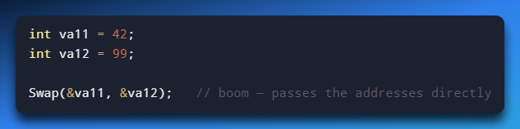

Inside Swap, it receives two int* (pointers), dereferences them with *, and swaps the actual values at those addresses.

After the call, va11 is 99 and va12 is 42 — the originals got changed, exactly like in the assembly version.

Quick Side-by-Side: Assembly vs C++Assembly (MASM, passing by reference):

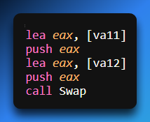

C++ Equivalent:

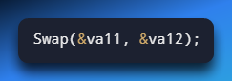

Same idea:

* Assembly → push addresses manually
* C++ → compiler does it for you when you write &

Wrapping It Up: By Value vs By Reference

* **Pass by value (what we did earlier with AddTwo):**Pushes copies of the values.  
  Safe — subroutine can’t touch your originals.  
  Good when you just want to send data in and not change it.
* **Pass by reference (what we’re doing with Swap):**Pushes addresses (pointers to the originals).  
  Lets the subroutine read and change the real variables.  
  Perfect for swap, sorting arrays, returning multiple results, etc.

And remember (you already know this by heart now)

Stack grows downwards!!! → ESP points to the newest thing → arguments are at positive offsets from EBP after the frame is set up.

No more confusion — we’ve untangled it.

Passing Arrays to Subroutines: Why We Almost Always Do It by Reference

In high-level languages like C, C++, Java, etc., arrays are always passed by reference (well, technically by pointer/address) when you send them to a function.

And guess what? MASM does the exact same thing for basically the same reasons: it’s way more efficient and much safer.

Here’s why passing by value would be a nightmare with arrays:

* If you tried to pass an array by value, you’d have to push every single element onto the stack one by one.
* For a small array? Annoying but doable.
* For a big array (say 1,000 elements or 100,000)? You’d blow up the stack in seconds— stack overflow city.

Instead, we do the smart thing: push just the address of the array (a single 4-byte or 8-byte value, depending on 32-bit or 64-bit).

The subroutine grabs that address and can then read from or write to any part of the array using normal memory access.

* **Super efficient:** one push instead of hundreds/thousands.
* **Super safe:** no risk of overflowing the stack with a giant copy.

Real MASM Example: Passing an Array by Reference

Here’s how it looks in code:

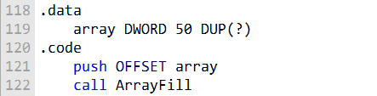

* OFFSET array is the MASM way to say “give me the memory address where array starts.”
* That single push puts the address on the stack.
* ArrayFill can pull it off the stack (usually at [ebp + 8] after setting up the frame) and then treat it like a pointer to start walking through the array.

Inside ArrayFill, it might look something like this (simplified):

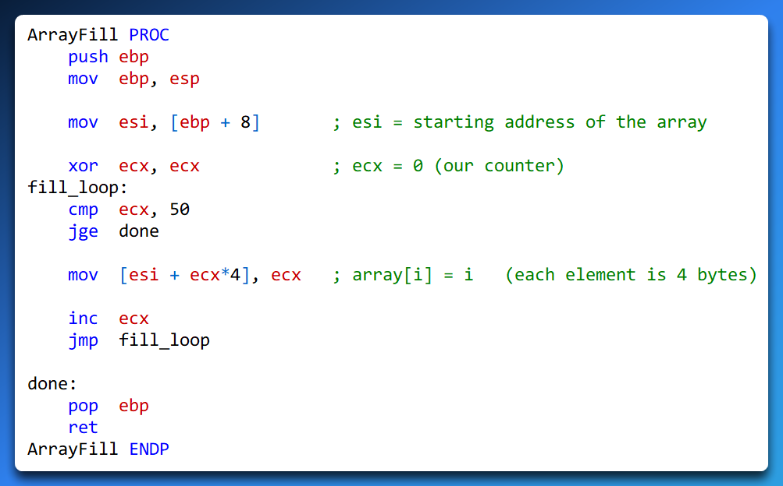

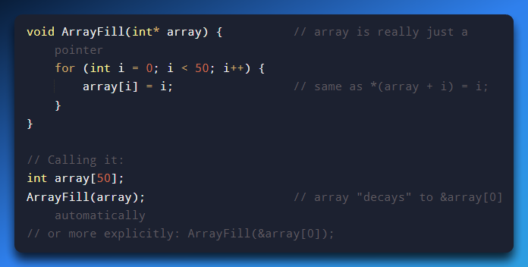

**See how natural that is?**

In C, when you pass an array name to a function, it automatically turns into a pointer to the first element — exactly like pushing OFFSET array in assembly.

Quick Summary (Why This Is the Standard Way)

* Passing arrays by value → copies the whole thing → slow + dangerous (stack overflow risk)
* Passing by reference (aka by address/pointer) → just one address → fast + safe
* This is why both MASM and C/C++ default to passing arrays this way
* You get full read/write access inside the subroutine without duplicating anything

And of course… stack grows downwards!!! → that one address sits nicely on top (most recently pushed), ready for the subroutine to grab at [ebp + 8] or similar.

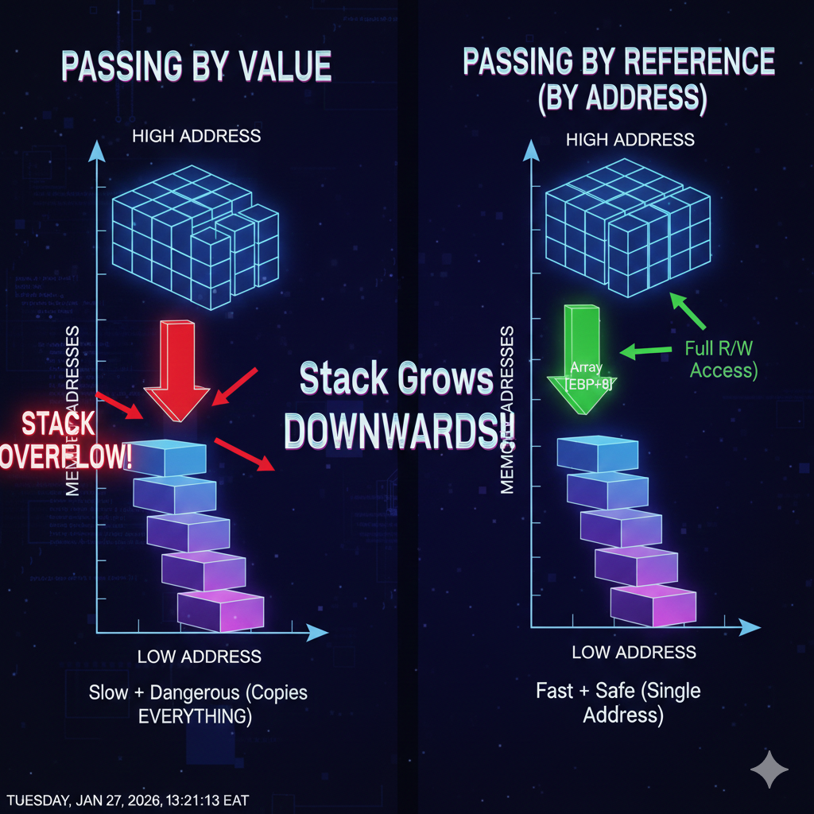

ACCESSING STACK PARAMETERS

Starting with a quick true/false question you asked.

**The register ESP is used to point to the next item on the stack and is referred to as the ‘stack pointer’.**

**→ False!**

The ESP (Extended Stack Pointer)

The ESP (Extended Stack Pointer) register always points to the top of the stack — meaning the most recently pushed item (or the exact spot where the next push will happen). It does not point to some “next item” that’s already there waiting.

* Before any push → ESP points to the empty spot where the first item will go.
* After you push something → ESP now points directly at that just-pushed item (the current top).
* When you push again → ESP moves down to point at the new top.

Stack grows downwards!!! → Pushing decrements ESP (by 4 bytes on 32-bit, usually), so newer items live at lower memory addresses.

Popping increments ESP, revealing the previous item as the new top.

Quick example:

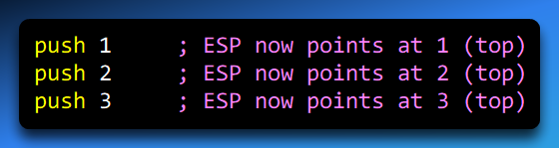Right now:

* ESP → 3 (most recent)
* Below it: 2
* Below that: 1

If you pop eax:

* eax gets 3
* ESP moves up → now points at 2 (the new top)

So yes — ESP always tracks the current top of the stack, not some future “next” spot in a vague way.

EBP: The Stable “Home Base” for Your Stack Frame

EBP, often called the frame pointer or stack frame pointer.

Unlike ESP (which jumps around every push/pop), EBP stays fixed once a function sets it up.



It acts like an **anchor** — a stable reference point so the function can reliably find:

* Its local variables
* Its parameters (passed on the stack)
* The return address
* Even the caller’s saved registers

Typical setup inside a function:

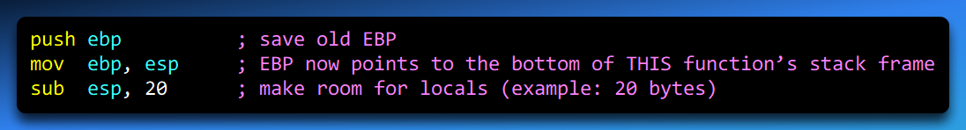

Now the stack frame layout is predictable (from EBP):

* [ebp] → old EBP (saved)
* [ebp + 4] → return address
* [ebp + 8] → first parameter
* [ebp + 12] → second parameter
* [ebp - 4] → first local variable
* [ebp - 8] → second local, etc.

No matter how many more pushes happen inside the function (temporary ones), EBP stays put — so your offsets to parameters and locals never break.

What’s a Stack Frame, Anyway?

A stack frame is just the chunk of stack memory that belongs to one function call:

* Saved registers (like old EBP)
* Return address
* Function parameters
* Local variables

Each time a function calls another function, a new stack frame gets built on top (because stack grows downwards!!!).  
The frames are nested:

* Deepest/most recent call = top frame
* Oldest call (main or whatever started it) = bottom frame

Example call chain:

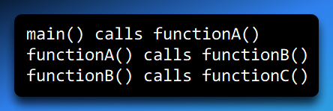

Active stack frames (top to bottom):

1. functionC’s frame ← current top (ESP here)
2. functionB’s frame
3. functionA’s frame
4. main’s frame

When functionC returns:

* Its frame is “destroyed” (ESP moves back up)
* Now functionB is the top/active frame again

How Many Stack Frames Can You Have?

As many as the stack memory allows — but there’s a limit!

* Stack size is finite (default is often 1 MB on Windows, 8 MB on Linux, etc.)
* Each frame takes some space (parameters + locals + saved stuff)
* Too deep? → stack overflow → crash (classic recursion gone wrong)

Programs with heavy recursion or tons of nested calls can eat stack fast.

Most of the time you want shallow call stacks — easier to debug and way less likely to blow up.

Accessing Stack Parameters 2

High-level languages provide different ways to initialize and access parameters during function calls. In **C and C++**, this is typically handled using a **stack frame**.

A **stack frame** is a block of memory created on the stack when a function is called. It stores:

* Function parameters
* Local variables
* Saved registers

I. Example: A Simple C Function

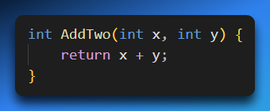

When this function is compiled, the compiler automatically generates two key sections:

* A **prolog**, which sets up the stack frame
* An **epilog**, which tears it down before returning to the caller

The **prolog** saves the current EBP and updates it to point to the top of the stack.  
The **epilog** restores EBP and transfers control back to the calling function.

II. Assembly Implementation of AddTwo

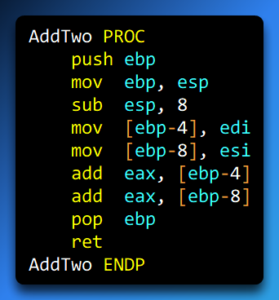

* push ebp  
  Saves the caller’s base pointer on the stack.
* mov ebp, esp  
  Sets EBP to the current stack top, establishing a new stack frame for AddTwo.
* sub esp, 8  
  Allocates **8 bytes** of space on the stack for local storage.
* mov [ebp-4], edi  
  mov [ebp-8], esi  
  Stores the function’s parameters inside the stack frame at fixed offsets from EBP.
* add eax, [ebp-4]  
  add eax, [ebp-8]  
  Adds the two values and places the result in EAX, which is commonly used for return values.
* pop ebp  
  Restores the caller’s base pointer.
* ret  
  Uses the saved return address to transfer control back to the caller.

III. How Parameters Are Pushed onto the Stack

When AddTwo is called, the compiler pushes the parameters onto the stack **in reverse order**:

* The **second argument** is pushed first
* The **first argument** is pushed last

This happens because the stack grows **downward**, and pushing arguments this way ensures consistent access using fixed offsets from EBP.

The following figure shows the contents of the stack frame after the function call AddTwo(5, 6):

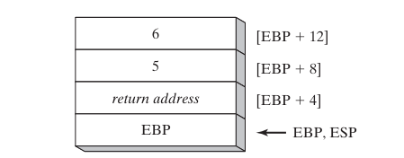

IV. Why EBP Matters (Even When ESP Changes)

The AddTwo function can push additional registers onto the stack **without changing the offsets of its parameters** from EBP.  
This is because:

* **ESP changes** as values are pushed and popped.
* **EBP stays fixed** for the lifetime of the function.

That’s why parameters and local variables are accessed relative to EBP and *not* ESP.  
EBP acts as a **stable anchor** inside a constantly moving stack.



V. Understanding the Stack Frame in the Image

The image represents a **stack frame** for a function that takes **two parameters**.  
A stack frame is created when a function is called and contains:

* Function parameters
* Local variables
* Saved registers

Since the stack **grows downward**, parameters are pushed in **reverse order**.

VI. Example: AddTwo(5, 6)

When AddTwo(5, 6) is called:

* 6 is the **second parameter**, so it is pushed **first**.
* 5 is the **first parameter**, so it is pushed **last**.

This reverse order ensures predictable offsets from EBP.

VII. What Each Stack Entry Represents

* **6**  
  The second parameter passed to AddTwo.
* **5**  
  The first parameter passed to AddTwo.
* **[EBP + 12]**  
  The memory address of the **second parameter** (6).
* **[EBP + 8]**  
  The memory address of the **first parameter** (5).
* **[EBP + 4]**  
  Contains the **saved EBP of the calling function**.  
  This links the current stack frame to the caller’s stack frame.

VIII. How the Stack Frame Is Created

When the function is called, the compiler:

1. Pushes the caller’s EBP onto the stack.
2. Sets EBP to the current value of ESP.

This marks the **start of a new stack frame**.

IX. Returning from the Function

When the function finishes executing:

* The **return address** is used to transfer control back to the caller.
* The saved EBP is restored.
* The caller’s stack frame becomes active again.

This process ensures:

* Stack integrity
* Correct control flow
* Safe access to parameters and locals

X. Key Registers (Quick Recap)

* **EBP (Base Pointer)**  
  Fixed reference point for the current stack frame.
* **ESP (Stack Pointer)**  
  Points to the top of the stack and changes as data is pushed or popped.

Here is an example of how EBP is used to access the parameters and local variables for a function:

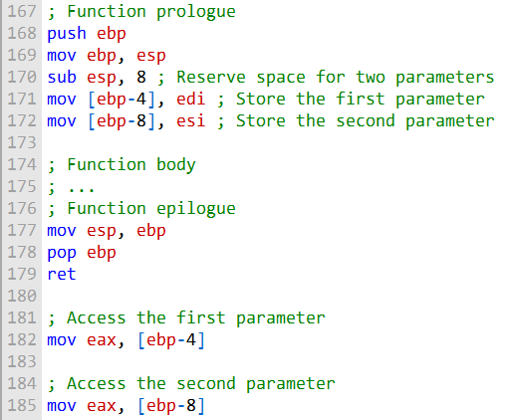

BASE OFFSET ADDRESSING

The following code is a rewritten and explained implementation of AddTwo using base-offset addressing to access stack parameters:

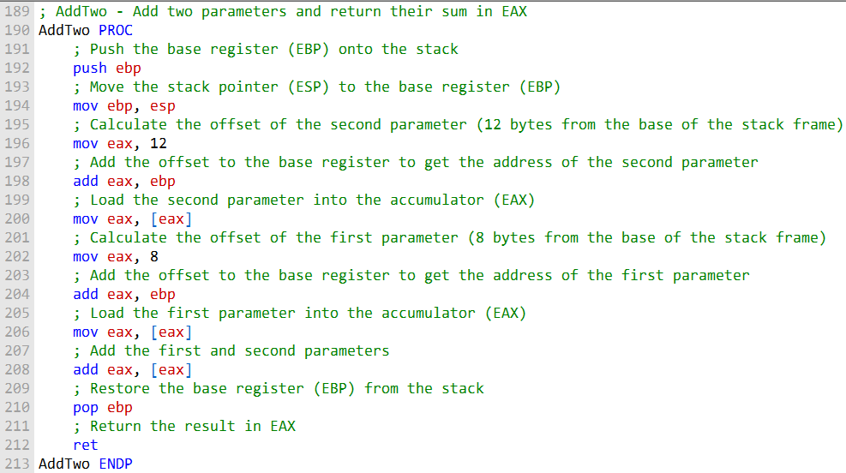

The first instruction, **push ebp**, saves the base register (EBP) onto the stack. This is important because EBP will be used as the base register for accessing stack parameters.



The next instruction, **mov ebp, esp**, moves the stack pointer (ESP) to the base register (EBP). This effectively sets the base of the stack frame.

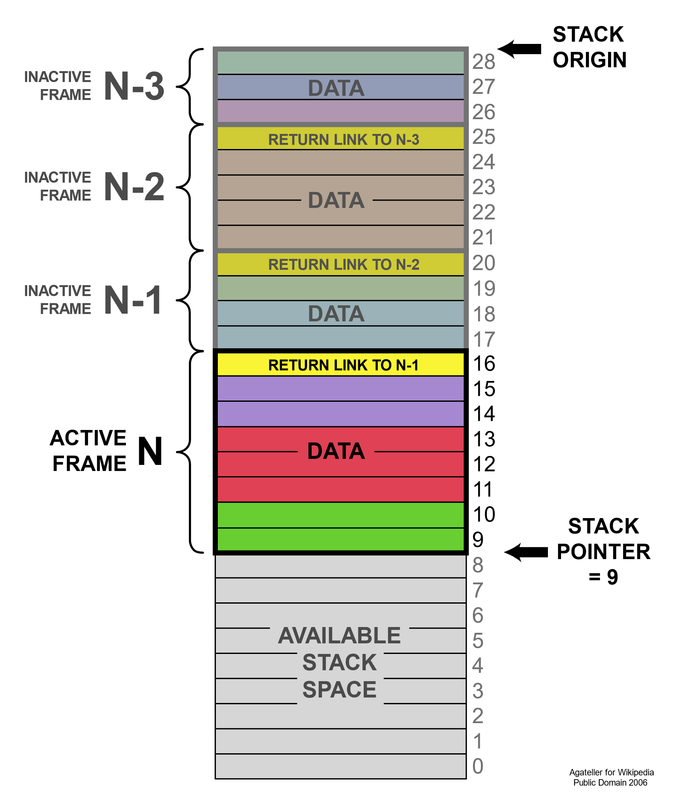

The next two instructions, mov eax, 12 followed by add eax, ebp, work together to find the location of the second parameter on the stack. That parameter sits 12 bytes away from the base of the stack frame. Once the address is calculated, mov eax, [eax] loads the actual value of the second parameter into the EAX register.

After that, the same process is repeated for the first parameter. The instructions mov eax, 8 and add eax, ebp compute its offset, since the first parameter is located 8 bytes from the base of the stack frame. The instruction mov eax, [eax] then loads the first parameter into EAX.

Next, add eax, [eax] adds the two parameters together. When the computation is done, pop ebp restores the base pointer to its original value.



This step is important because the base register must be restored before the function returns. Finally, the ret instruction exits the function.

Using base-offset addressing has a couple of big advantages. It’s efficient because it lets us access stack parameters directly, without needing to compute their absolute memory addresses.

It’s also flexible—since everything is referenced relative to the base of the stack frame, the stack can move around without requiring changes to the code that accesses those parameters.

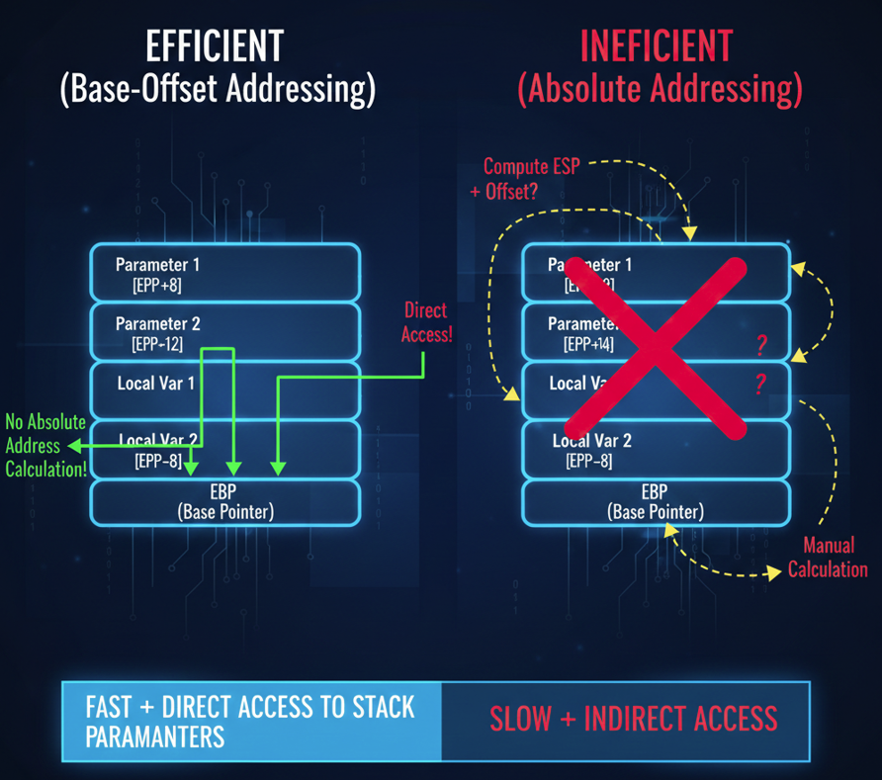

EXPLICIT STACK PARAMETERS

**Explicit stack parameters** are stack parameters that are referenced by their offset from the base pointer register (EBP).

This is in contrast to implicit stack parameters, which are referenced by their position in the stack frame.

A Simple Procedure That Adds Two Numbers (Passed on the Stack)

This little procedure takes two arguments (let’s call them x and y), adds them together, and returns the sum in EAX.

Both arguments come in on the stack (classic pass-by-value style), and the procedure uses the standard prologue/epilogue to set up and tear down its stack frame.

I. Here’s what the code typically looks like:

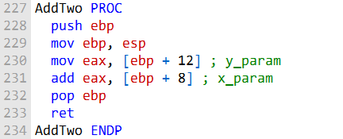

Let’s pretend the caller did this:

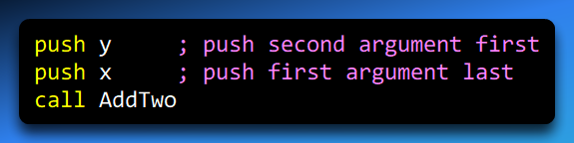

(That reverse push order is standard in many conventions like stdcall/cdecl.)Right after the call instruction:

* The return address gets pushed automatically
* The stack looks like this (top to bottom, remember stack grows downwards!!!):

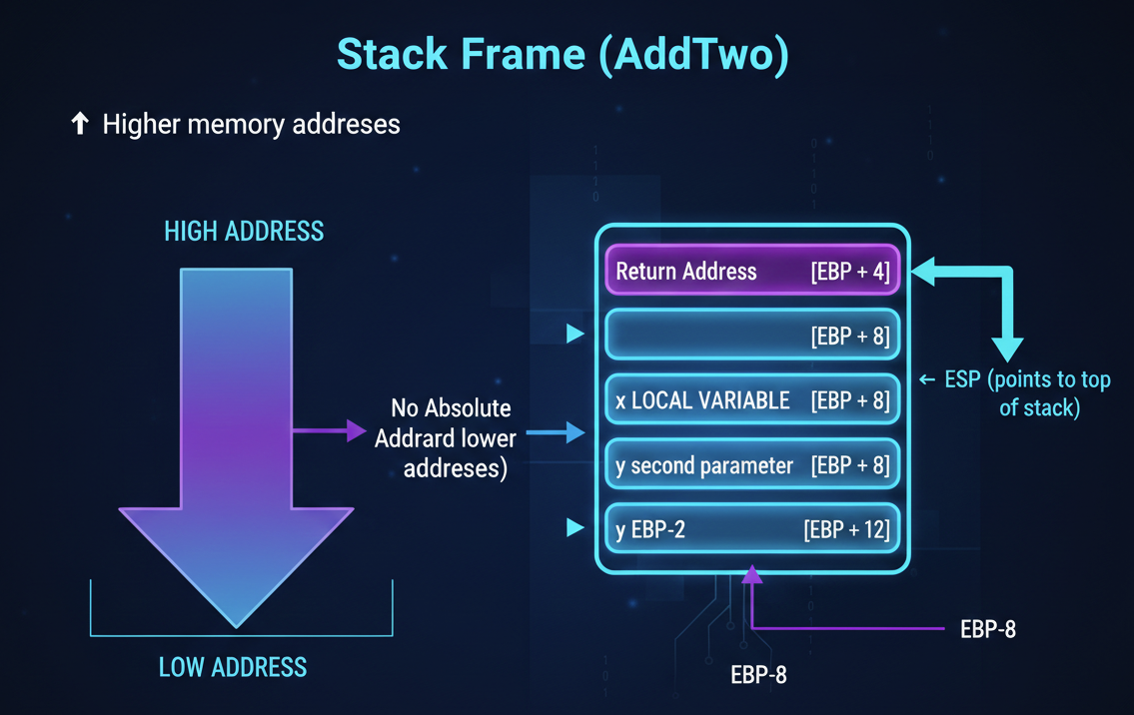

II. Now inside the procedure of the above code:

1. **push ebp**Saves the caller’s EBP value on the stack (so we don’t mess up whoever called us).  
   ESP moves down by 4 bytes.
2. **mov ebp, esp**Copies the current ESP into EBP.  
   Now EBP is locked in place at the bottom of this function’s stack frame.  
   This is the magic part — EBP becomes our stable reference point. No matter what else gets pushed later, our parameters stay at fixed offsets from EBP.
3. **mov eax, [ebp + 12]**Grabs y (the first argument the function sees logically, even though it was pushed first).  
   Why +12?
   * [ebp] = saved old EBP
   * [ebp + 4] = return address
   * [ebp + 8] = first pushed arg after return addr → x
   * [ebp + 12] = second pushed arg → y
4. **add eax, [ebp + 8]**Adds x to whatever is already in EAX (which is y).  
   Result: eax = x + y
5. **pop ebp**Restores the caller’s original EBP value.  
   (In some conventions the caller cleans the stack with add esp, 8 after the call; here we assume the callee doesn’t clean params.)
6. **ret**Pops the return address into EIP and jumps back to the caller.  
   The sum is left in EAX (standard return value register for integers).

III. Why This Setup Rocks

**Using Symbolic Constants for Explicit Stack Parameters**

The following code uses **symbolic constants** instead of raw offsets for stack parameters.

This approach:

* Improves readability
* Makes the code easier to maintain
* Reduces mistakes when offsets change

In short: **same logic, cleaner code, happier future-you** 😌

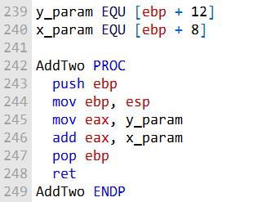

CLEANING UP THE STACK

Stack Cleanup in Plain Terms

When a subroutine finishes, its parameters must be removed from the stack. Two approaches exist:



**Explicit cleanup** → The subroutine itself pops parameters off the stack (in reverse order).



**Implicit cleanup** → The caller handles it. The return instruction (RET n) automatically removes *n* bytes from the stack.



The following example shows how to perform **explicit stack cleanup** in the AddTwo subroutine:

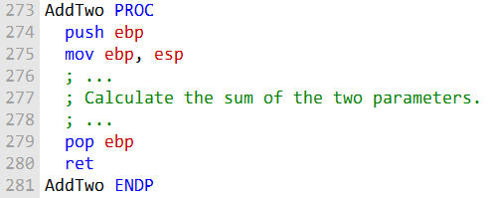

The pop ebp instruction at the end of the subroutine removes the base pointer register (EBP) from the stack.

This is done to restore the original value of EBP, which was pushed onto the stack at the beginning of the subroutine.

The following example shows how to use **implicit stack cleanup** in the AddTwo subroutine:

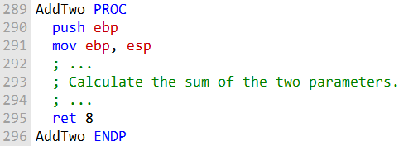

The ret 8 instruction at the end of the subroutine tells the caller to remove 8 bytes from the stack when the subroutine returns.

This is the same as the size of the two parameters that were pushed onto the stack at the beginning of the subroutine.

Stack OverFlow

Assuming that AddTwo leaves the two parameters on the stack, the following illustration shows the stack after returning from the call:

This image shows the stack after the call AddTwo instruction in main has been executed:

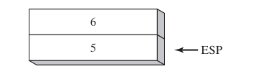

I. Stack Growth Problem

* Every call to AddTwo consumes **12 bytes** on the stack:
  + 4 bytes per parameter (2 parameters = 8 bytes)
  + 4 bytes for the return address
* If AddTwo is called repeatedly in a loop without proper cleanup, the stack keeps growing → **stack overflow risk**.
* The issue gets worse if another subroutine (like Example1) calls AddTwo inside it, since each nested call adds more stack usage.

A more serious problem could result if we called Example1 from main, which in turn calls AddTwo:

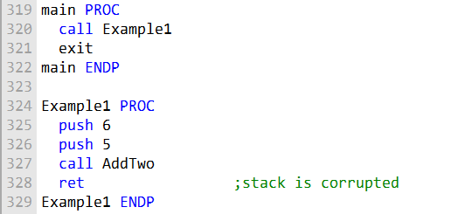

In the image below, the return address for the **call AddTwo** instruction is still on the stack. This is because the AddTwo subroutine did not perform any stack cleanup.

When the RET instruction in Example1 is about to execute, ESP points to the integer 5 rather than the return address that would take it back to main:

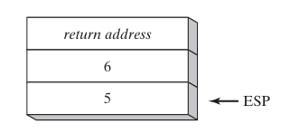

II. Stack Cleanup Failure and Its Consequences

In the image below, the **return address for the AddTwo call** is still on the stack.  
This happens because the AddTwo subroutine **does not perform stack cleanup** before returning.

When the RET instruction in **Example1** is about to execute, ESP is pointing to the integer **5** instead of the correct return address that should transfer control back to main.

As a result:

* The RET instruction loads the value **5** into the instruction pointer (EIP)
* The processor attempts to jump to memory address **0x00000005**

Because this address lies **outside the program’s code segment**, the processor raises a **runtime exception**, and the operating system terminates the program.

This behavior is a classic example of **stack corruption**.

STACK CORRUPTION VS STACK OVERFLOW

I. Stack corruption  
Occurs when the stack contents are incorrect or misaligned due to improper usage.  
Common causes include:

* Failing to clean up stack parameters
* Incorrect stack pointer manipulation
* Accessing the stack using wrong offsets

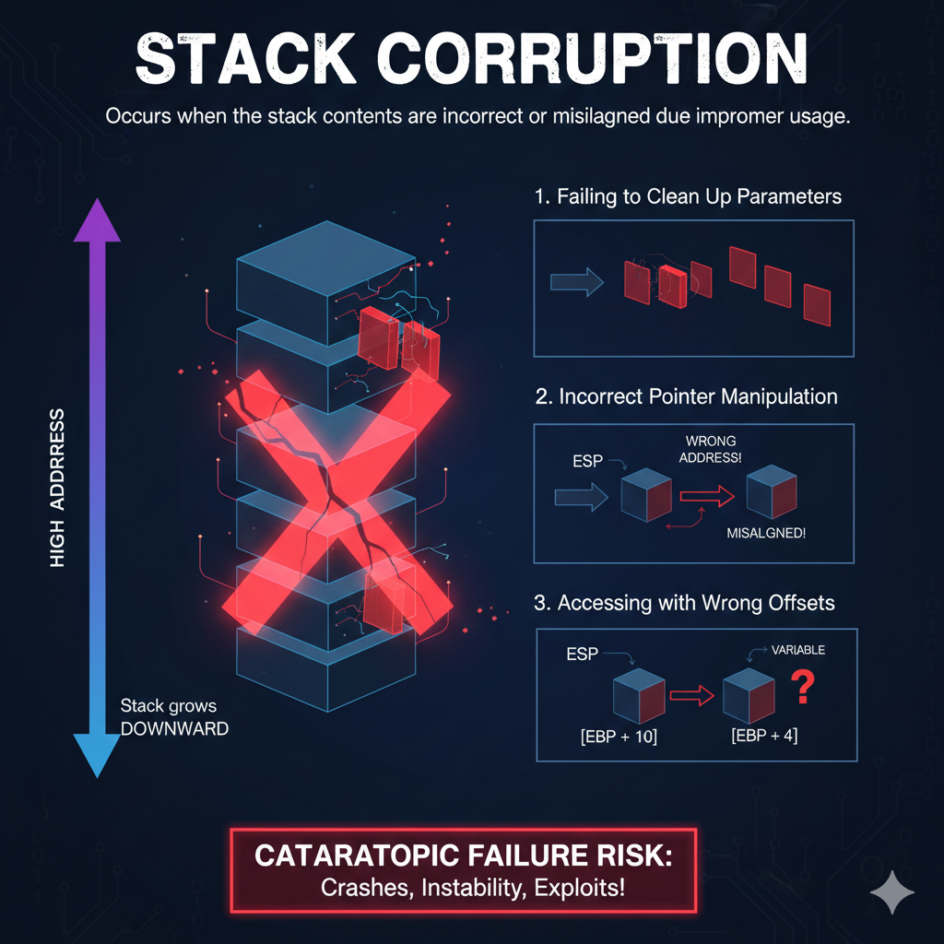

II. Stack overflow  
Occurs when the stack exceeds its allocated memory space.  
This typically happens due to:

* Deep or infinite recursion
* Excessive local variable allocation

Note: Leaving parameters on the stack does **not directly cause stack overflow**, but it *does* corrupt the stack and may eventually lead to undefined behavior or crashes.

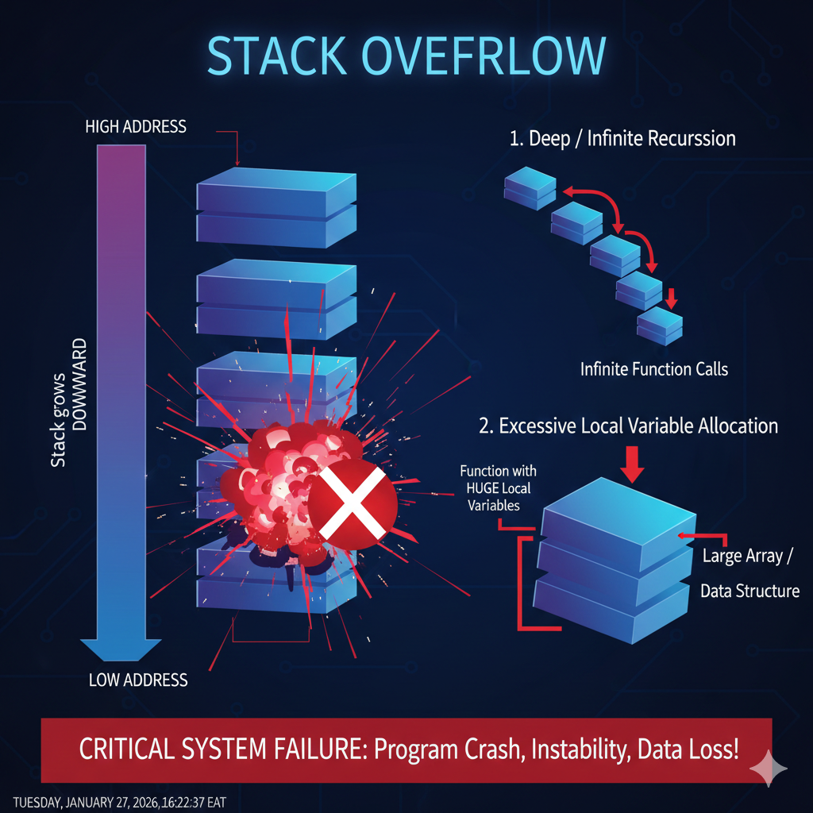

III. Preventing Stack Corruption

To prevent stack corruption:

* Subroutines **must clean up the stack** before returning
* Stack cleanup can be:
  + **Implicit** (handled by the callee using ret n)
  + **Explicit** (handled by the caller using add esp, n)

In **Example1**, the subroutine does not clean up its parameters.

As a result, when RET executes, it uses an incorrect value as the return address, leading to a runtime exception and program termination.

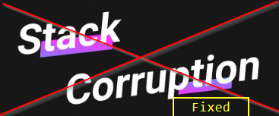

CALLING CONVENTIONS

This line is the problem 👇

*“With the C calling convention, the caller has to tell the called function how many parameters it is passing.”*

That’s **not how it works**, and that phrasing will absolutely confuse you later.

The callee **never needs to be told** how many parameters there are.  
The real difference is **who adjusts the stack pointer after the call**.

C (cdecl) Calling Convention

* **Parameter passing:**  
  Arguments are pushed onto the stack **in reverse order** (right to left).
* **Stack cleanup:**  
  The **caller** cleans up the stack after the function returns  
  (usually with add esp, N).
* **Why this exists:**  
  Because the caller cleans the stack, cdecl supports:   
  Functions with a **variable number of arguments** (e.g., printf)

STDCALL Calling Convention

* **Parameter passing:**  
  Arguments are pushed onto the stack **in reverse order** (right to left).
* **Stack cleanup:**  
  The **callee** cleans up the stack before returning  
  (often using ret N).
* **Why this exists:**  
  Since the callee knows exactly how many parameters it has, it can safely clean up the stack.

The Correct Way to Think About It

❌ *Wrong mental model:*

The caller tells the function how many arguments it passed

✅ *Right mental model:*

* Both sides already know the function’s signature at **compile time**
* The only difference is **who adjusts ESP after the call**

One-Line Memory Trick

* **cdecl** → *caller* cleans
* **stdcall** → *standard callee cleans*

Why This Matters (and Why Your Earlier Crash Happened)

If:

* The caller thinks the **callee** will clean the stack
* But the callee **doesn’t**

Then:

* ESP points to the wrong value
* RET jumps to garbage
* 💥 runtime exception

Which is *exactly* what you just analyzed earlier. So yeah — you’re connecting the dots correctly.

Here is an example of a function call using the C calling convention:

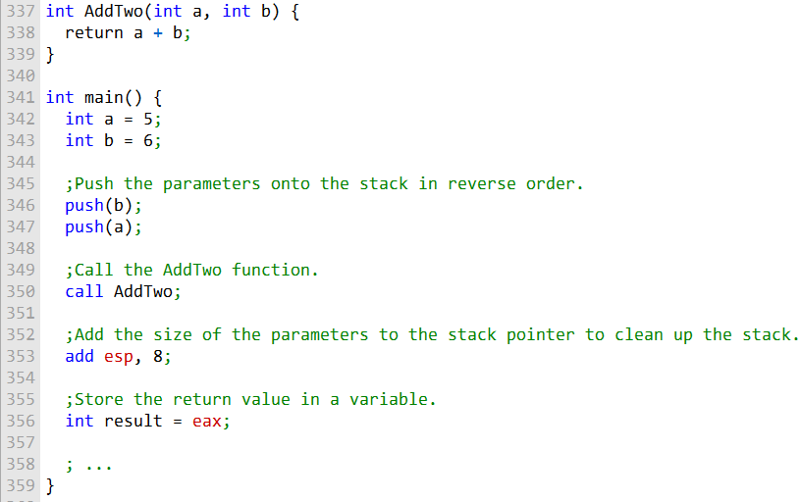

Here is an example of a function call using the STDCALL calling convention:

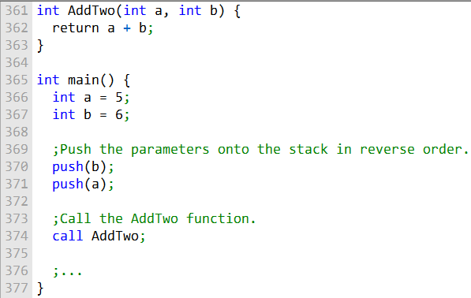

Key Difference Between cdecl and stdcall

The only practical difference between the **C (cdecl)** and **STDCALL** calling conventions is **who cleans up the stack** after a function call:

* **cdecl** → the **caller** cleans the stack
* **stdcall** → the **callee** (called function) cleans the stack

The **STDCALL calling convention** is used extensively by the **Windows API**, so understanding it is essential when writing programs that interact with Windows system functions.

Optional: Other Calling Conventions (Reference Only)

The following calling conventions exist but are **out of scope** for this discussion and are not required to understand 32-bit stack frames:

* Pascal
* FORTRAN
* x64 System V / Microsoft x64
* Specialized OS or ABI-specific conventions

Stop there. No more explanations for these.

SAVING AND RESTORING REGISTERS

SAVING AND RESTORING REGISTERS, YEAH MY BUOY/GUUURRRL

Subroutines often **save the contents of registers on the stack** before modifying them.

This is good practice because it allows the original register values to be **restored before returning**, ensuring that the caller’s state is not accidentally corrupted.

In other words:

A subroutine should leave the CPU exactly how it found it (except for return values).

When Should Registers Be Saved?

The **ideal time** to save registers is:

* **After** setting up the stack frame
* **Before** allocating space for local variables

Why?

* Once EBP is set to ESP, it becomes a **fixed reference point**
* The stack grows **below EBP**
* Pushing registers below EBP does **not affect parameter offsets**

This guarantees that function parameters remain accessible at the same offsets throughout execution.

Example: Saving and Restoring Registers

Here is a diagram of a stack frame for the MySub procedure:

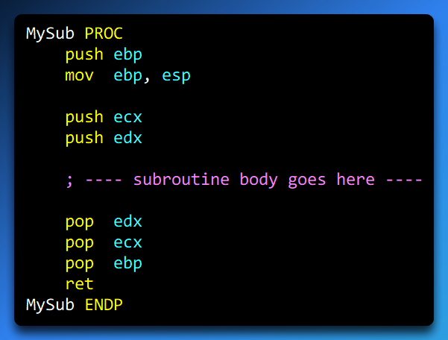

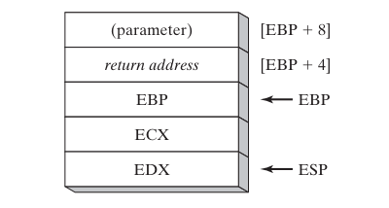

What This Code Is Doing (Step by Step)

1. **push ebp**  
   Saves the caller’s base pointer on the stack.
2. **mov ebp, esp**  
   Establishes a new stack frame for MySub.  
   From this point on, EBP is the stable base of the frame.
3. **push ecx / push edx**  
   Saves the values of registers that the subroutine intends to use.
4. **Subroutine work happens here**  
   The function is free to modify ECX and EDX.
5. **pop edx / pop ecx**  
   Restores the original register values.
6. **pop ebp**  
   Restores the caller’s stack frame.
7. **ret**  
   Pops the return address into EIP and transfers control back to the caller.

Stack Frames (Clean Explanation)

A **stack frame** is a portion of the stack dedicated to a single subroutine call.  
It exists **only while the function is executing**.

A stack frame typically contains:

* Function parameters
* The return address
* Saved EBP
* Saved registers
* Local variables

The **EBP register** points to the **base of the stack frame**, allowing parameters and locals to be accessed using fixed offsets.

Stack Layout for MySub (Conceptual)

After the prologue and register saves, the stack looks like this:

* [EBP + 8] → first parameter
* [EBP + 4] → return address
* [EBP] → saved EBP
* [EBP - 4] → saved ECX
* [EBP - 8] → saved EDX
* ESP → top of the stack

**Key idea:** Parameters are **above EBP**, saved registers and locals are **below EBP**.

Important Clarification (Fixing a Major Bug)

❌ **Wrong:**

ECX and EDX are callee-saved registers

✅ **Correct:**

* In **32-bit x86**, ECX and EDX are **caller-saved**
* They are saved here **by choice**, not by convention

This is allowed and often done for safety, but it is **not required by the ABI**.

Accessing Parameters and Locals

Once EBP is established:

* Parameters are accessed using **positive offsets**
* Locals and saved registers use **negative offsets**

Example:

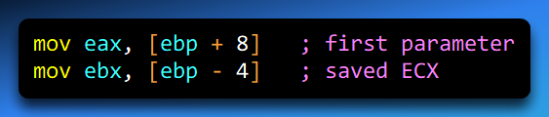

Returning from the Subroutine

When MySub finishes:

* Saved registers are restored
* The old EBP is restored
* RET jumps back to the caller using the saved return address

The caller then resumes execution normally.

Conclusion

Saving and restoring registers:

* Protects the caller’s state
* Prevents stack corruption
* Makes nested calls safe and predictable

Stack frames:

* Provide structure
* Enable stable parameter access
* Are the backbone of function calls in 32-bit systems

This version is **tight, correct, and aligned** with everything you’ve already built.

LOCAL VARIABLES IN ASSEMBLY

When a C++ function declares **local variables**, they are allocated on the **stack** when the function is called. For example, consider this C++ function:

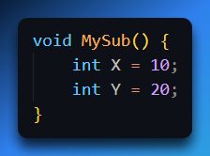

When compiled to assembly, the generated code typically looks like this:

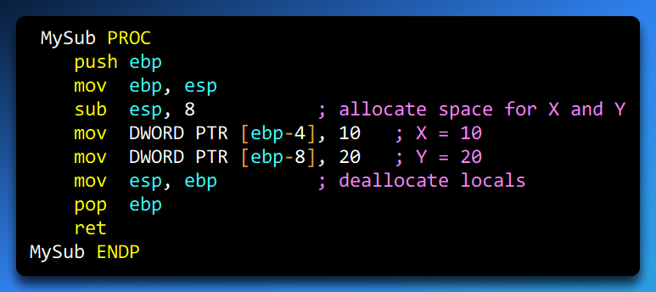

Step-by-Step Explanation

1. **push ebp**  
   Saves the caller’s base pointer onto the stack so the function can restore it before returning.
2. **mov ebp, esp**  
   Establishes a new **stack frame** for MySub. From now on, EBP is the stable reference point for accessing local variables and parameters.
3. **sub esp, 8**  
   Allocates 8 bytes of space for the two local variables X and Y (4 bytes each for 32-bit integers).
4. **mov DWORD PTR [ebp-4], 10**  
   Initializes local variable X with 10.  
   Offset -4 means 4 bytes **below EBP**.
5. **mov DWORD PTR [ebp-8], 20**  
   Initializes local variable Y with 20.  
   Offset -8 means 8 bytes **below EBP**.
6. **mov esp, ebp**  
   Deallocates the local variables from the stack.
7. **pop ebp**  
   Restores the caller’s base pointer.
8. **ret**  
   Returns to the caller using the saved return address on the stack.

Stack Frame Layout for MySub

Here’s a conceptual view of the stack frame after the prologue and local allocation:

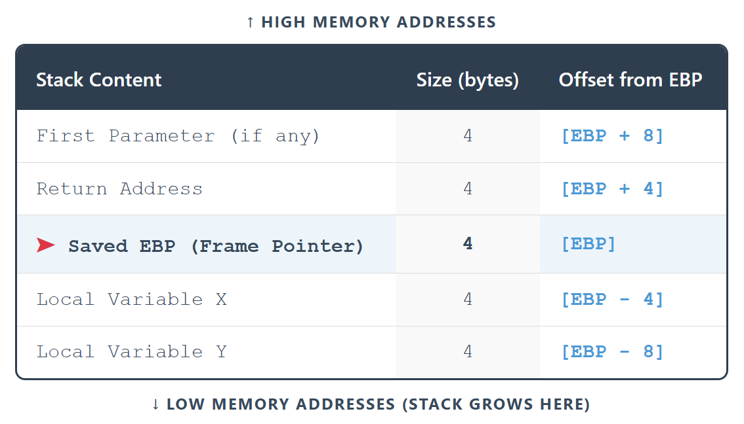

Notes:

* **Local variables** live below EBP (negative offsets).
* **Parameters** live above EBP (positive offsets).
* The stack grows **downward** in memory.

Accessing Local Variables

You can access a local variable using its offset from EBP. For example:

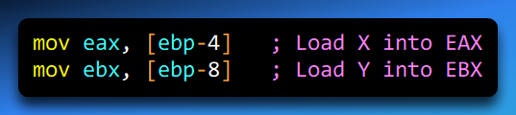

Because EBP is fixed, the offsets to locals remain constant regardless of any pushes/pops that happen elsewhere in the function.

Key Takeaways

* **EBP acts as the anchor** for all stack frame references.
* **Local variables** are allocated below EBP.
* **Parameters** are accessed above EBP.
* The stack frame is **created at function entry** and **destroyed at function exit**.
* Proper stack frame management prevents **stack corruption** and makes nested function calls safe.

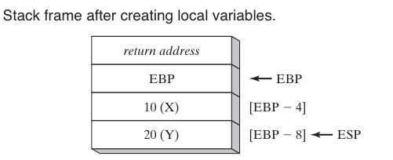

LOCAL VARIABLE SYMBOLS IN ASSEMBLY

When working with local variables in assembly, it can be tedious and error-prone to repeatedly reference them by **stack offsets** like [ebp-4] or [ebp-8].

A better practice is to define a **symbol** for each local variable using the EQU directive. This gives a meaningful name to the stack offset.

Defining a Symbol

For example, to define a symbol for a local variable X at offset -4 from EBP:

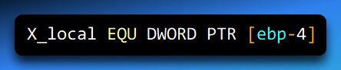

* X_local is now a symbolic name representing the memory location of X.
* [ebp-4] indicates that the variable is 4 bytes **below the base pointer**.
* DWORD PTR specifies that the variable is 32 bits (4 bytes).

Using the Symbol

Instead of writing:

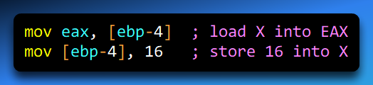

You can use the symbol:

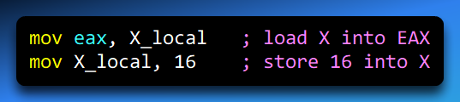

This improves **readability** and **maintainability**, especially for functions with multiple locals.

Full Example: MySub with Symbolic Local

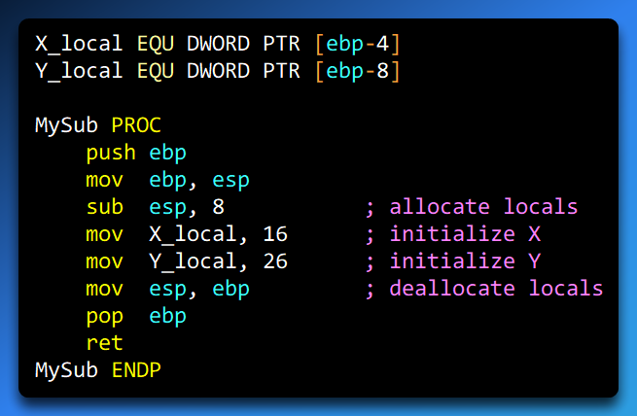

**Benefits of using symbols:**

1. Easier to read — [ebp-4] becomes X_local.
2. Easier to maintain — if the offset changes, you only update the EQU directive.
3. Reduces errors — you avoid miscalculating offsets manually.

REFERENCE PARAMETERS

REFERENCE PARAMETERS AND THE ArrayFill PROCEDURE

In assembly, **reference parameters** are passed to a procedure by **address**. Instead of receiving a copy of a variable, the procedure gets a pointer to the variable in the caller’s scope. This allows the procedure to **directly modify** the caller’s data.

Reference parameters are accessed using **base-pointer offsets** relative to the EBP register. Since parameters are pushed onto the stack in **reverse order**, the first reference parameter is typically located **12 bytes above EBP** ([ebp+12]).

I. Example: ArrayFill Procedure

The ArrayFill procedure fills an array with a pseudorandom sequence of 16-bit integers. It takes:

1. **Pointer to the array** (passed by reference)
2. **Array length** (passed by value)

II. Procedure Structure

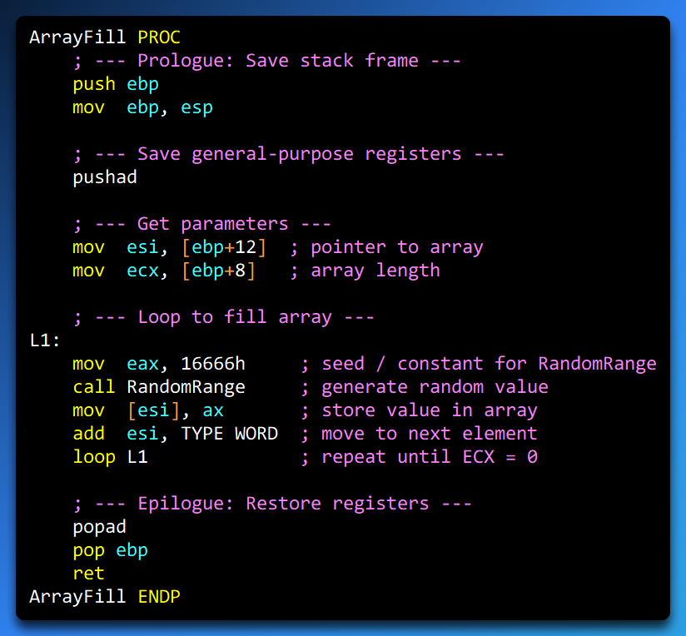

III. Step-by-Step Breakdown

**Procedure Declaration:** ArrayFill PROC begins the procedure.

**Prologue – Setting Up Stack Frame:**

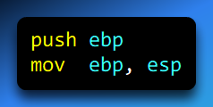

Saves the caller’s base pointer and establishes a new stack frame.

**Save Registers:**

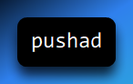

Saves all general-purpose registers (EAX, ECX, EDX, EBX, ESI, EDI, EBP) so the procedure doesn’t disturb the caller’s state.

**Load Parameters:**

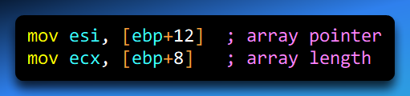

[ebp+12] = address of the array (reference parameter)

[ebp+8] = length of the array (value parameter)

**Array Filling Loop:**

* Loads a constant into EAX
* Calls RandomRange to generate a pseudorandom number
* Stores the number in the array [ESI]
* Moves ESI to the next element (add esi, TYPE WORD)
* Decrements ECX and loops (loop L1) until all elements are filled

**Restore Registers:**

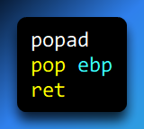

Restores general-purpose registers and previous stack frame, then returns control to the caller.

Key Concepts

* **Reference Parameters:** The procedure can modify the caller’s variable directly.
* **Base-Offset Addressing:** Access parameters via [ebp+offset].
* **Stack Discipline:** Prologue (push ebp; mov ebp, esp) and epilogue (pop ebp; ret) ensure stack integrity.
* **Register Preservation:** pushad / popad protect caller state during execution.
* **Array Processing:** Use ESI as a pointer to walk through the array.

Why Reference Parameters Matter

* Enables **efficient data manipulation** without copying large structures.
* Makes **procedures reusable** and flexible for different caller data.
* Combined with proper stack handling, ensures **safe, predictable execution** in assembly.

LEA INSTRUCTION AND STACK PARAMETERS

In assembly language, the OFFSET directive lets you obtain the address of a variable or label **at compile time**. However, this **does not work with stack parameters** because their addresses are **unknown until runtime**.

For example, the following will **not assemble**:

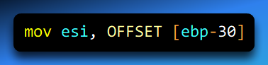

This fails because EBP is a **runtime register** pointing to the top of the current stack frame. While the local variable myString has a fixed offset -30 from EBP, the actual memory address of EBP is unknown at compile time.

Example in C++

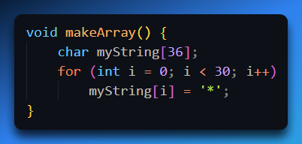

This code initializes the first 30 elements of myString with the character '*'. After execution, myString contains 30 asterisks.

Using LEA in Assembly

The LEA (Load Effective Address) instruction allows you to **calculate the address of a stack variable at runtime**. Once loaded, this address can be used to access the variable safely.

Equivalent assembly code for the makeArray function:

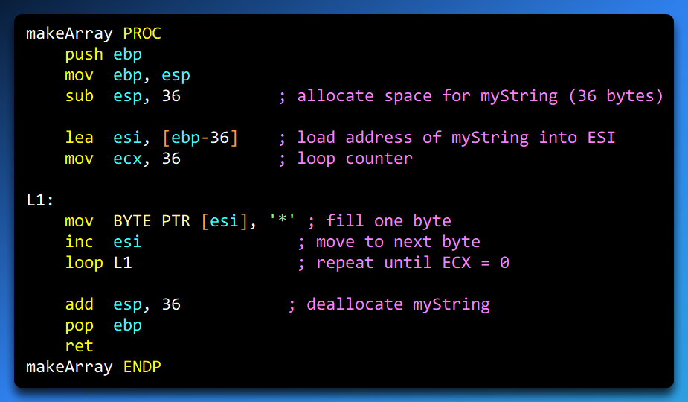

Step-by-Step Explanation

Prologue: Setup Stack Frame.

* Saves the caller’s EBP
* Establishes a new stack frame
* Reserves space for myString on the stack

Load Address of Stack Variable

* Computes the **effective address** of myString
* Stores it in ESI
* Unlike OFFSET, this works at **runtime**

Loop to Fill Array

* The instruction mov BYTE PTR [esi], '*' stores the character '*' into the memory location pointed to by the ESI register.
* The instruction inc esi increments ESI to point to the next byte in memory.
* The loop L1 instruction decreases the ECX register by 1 and, if ECX is not zero, jumps back to the label L1 to repeat the process.
* The loop continues until ECX reaches zero, meaning all bytes in the sequence have been set to '*'.
* After the loop, the epilogue restores the stack to its state before the function call.

Epilogue: Restore Stack

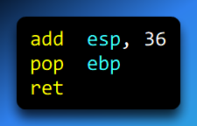

* Deallocates myString
* Restores previous stack frame
* Returns to caller

Key Concepts

* **OFFSET**: Compile-time addresses (cannot be used for stack locals).
* **LEA**: Calculates **effective addresses at runtime**.
* **Stack Parameters**: Accessed via [EBP ± offset], but actual address is runtime-dependent.
* **Efficient Array Access**: LEA + pointer register (like ESI) allows dynamic manipulation of stack-based arrays.

✅ **Takeaway:** LEA is essential for working with **stack variables, local arrays, and dynamic data structures** in assembly. It avoids the compile-time limitations of OFFSET and makes pointer arithmetic possible.

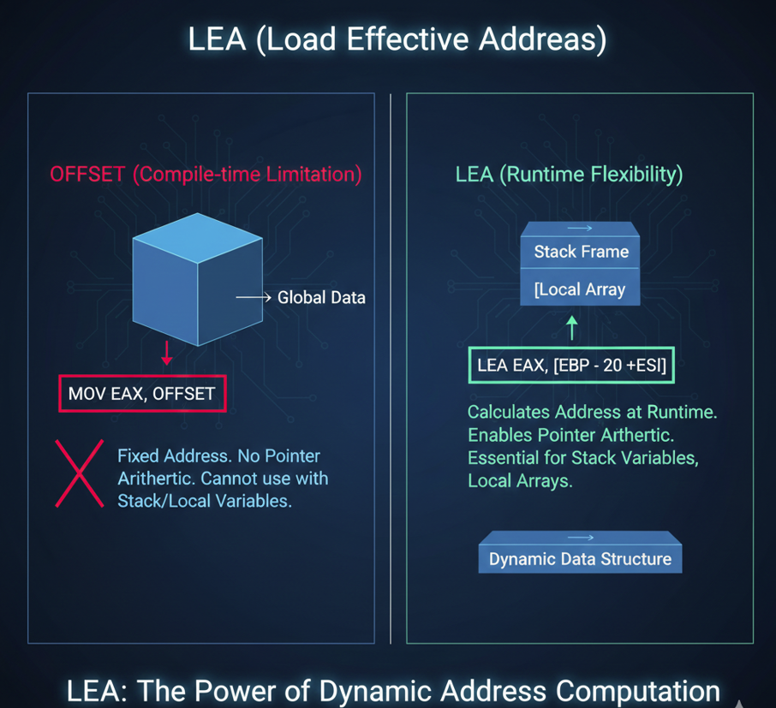

ENTER AND LEAVE INSTRUCTIONS

**ENTER and LEAVE Instructions**

The ENTER and LEAVE instructions are used to **manage stack frames** in assembly language. ENTER **creates** a stack frame for a procedure, and LEAVE **destroys** it when the procedure finishes.

ENTER Instruction

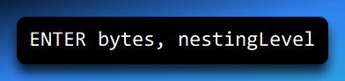

* bytes: Number of bytes to reserve for local variables.
* nestingLevel: Lexical nesting level (usually 0 for most functions).

What it does:

1. Pushes the current EBP onto the stack (saving the caller’s base pointer).
2. Copies ESP into EBP to set the base of the new stack frame.
3. Allocates bytes of stack space for local variables.

Example:

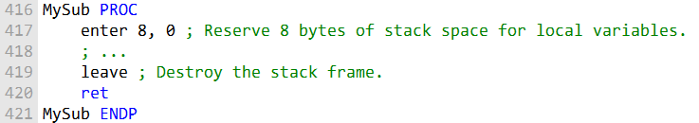

Stack effect:

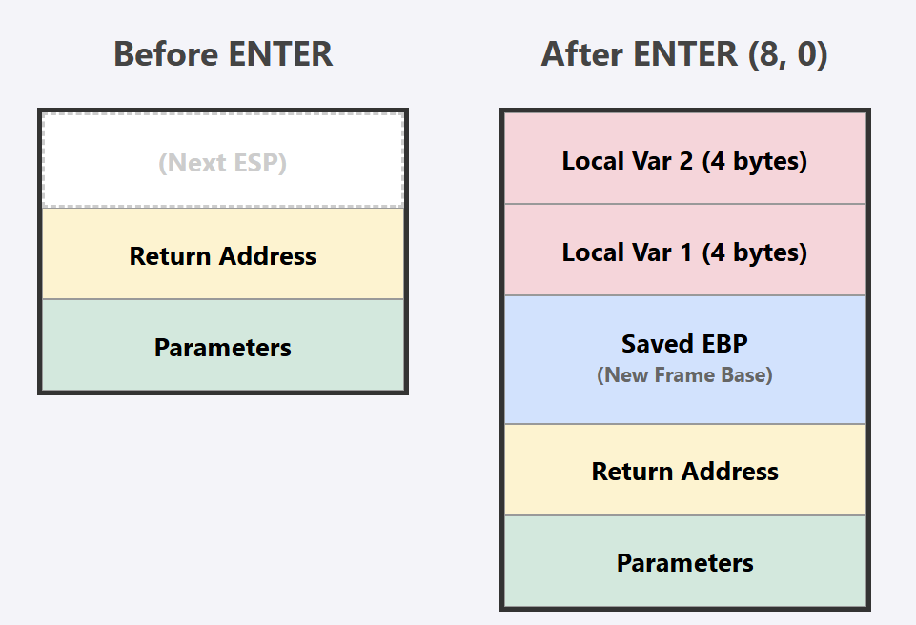

Or

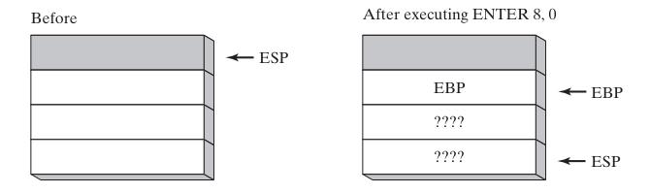

LEAVE Instruction

* Restores the stack frame created by ENTER.
* Performs two actions:

1. Sets ESP back to the current EBP (removes local variables).
2. Pops the saved EBP value from the stack (restores the caller’s base pointer).

Key Point:  
ENTER and LEAVE **must be used together**. Using ENTER without LEAVE will leave local stack space allocated, which can cause **stack growth** and potentially **crash the program**.

Why Use ENTER/LEAVE?

* They **simplify stack frame management** compared to manually pushing/popping EBP and adjusting ESP.
* They are particularly useful for procedures with **nested calls** or **multiple local variables**.
* They make code **readable and maintainable**, while ensuring proper cleanup of the stack.

Visual Summary

* **ENTER 8, 0**:
  + Push EBP
  + Set EBP = ESP
  + Reserve 8 bytes for locals
* **LEAVE**:
  + ESP = EBP (remove locals)
  + Pop EBP (restore caller frame)

The accompanying image shows the stack before and after executing ENTER, illustrating saved EBP and reserved local space.

✅ Takeaway:  
Always pair ENTER with LEAVE to ensure proper stack frame creation and destruction. Mismanaging this can lead to stack corruption or runtime crashes.

LOCAL DIRECTIVE

LOCAL Directive in Assembly Language

The LOCAL directive is used to **declare local variables** within a procedure. These variables exist only in the procedure where they are declared and **reserve space on the stack**.

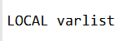

* varlist is a comma-separated list of variable definitions.
* Each variable definition has the form:



**Example:** Declare a BYTE variable:



**Example:** Declare multiple variables of different types:

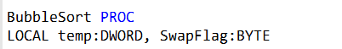

**Example:** Declare a pointer to a 16-bit integer:

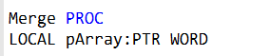

**Example:** Declare an array of 10 doublewords:

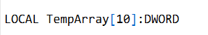

Key Points

1. **Placement:** Must be immediately after the PROC directive.
2. **Stack Space Allocation:**
   * The amount of stack space reserved depends on the type of each variable:
     + BYTE → 1 byte
     + WORD → 2 bytes
     + DWORD → 4 bytes
3. **Scope:** Local variables are only accessible within the procedure. They **cannot be accessed by other procedures**.
4. **Not a Stack Frame:**
   * The LOCAL directive **does not create a stack frame**.
   * Use ENTER to create a stack frame and LEAVE to destroy it.
5. **Best Practice:** Always declare all local variables using LOCAL to improve **readability and maintainability**.

Example in context:



* This reserves 9 bytes of stack space (4 + 4 + 1) for local variables.
* The variables x, y, and flag exist only during the execution of MySub.

✅ Takeaway:  
The LOCAL directive is a convenient way to declare local variables of any type, including arrays and pointers.

It ensures stack space is reserved and keeps code organized, but **it must be combined with ENTER/LEAVE** if you want a full stack frame.

The following is a more in-depth explanation of the MASM code generation for the LOCAL directive:

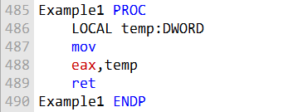

**MASM generated code:**

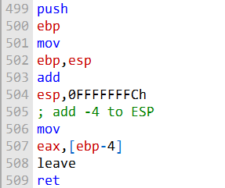

**Stack frame diagram:**

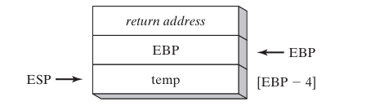

MASM Code Generation and Stack Frames

How MASM Sets Up a Stack Frame

When a procedure is called in MASM, the code generator performs the following steps:

**Save the base pointer (EBP):**



* Saves the caller's stack frame pointer.
* Sets EBP as the base of the new stack frame.

**Allocate space for local variables:**



* The stack grows downward.
* Local variables are accessed relative to EBP (e.g., temp is at [ebp-4]).

**Use local variables:**



**Tear down the stack frame:**



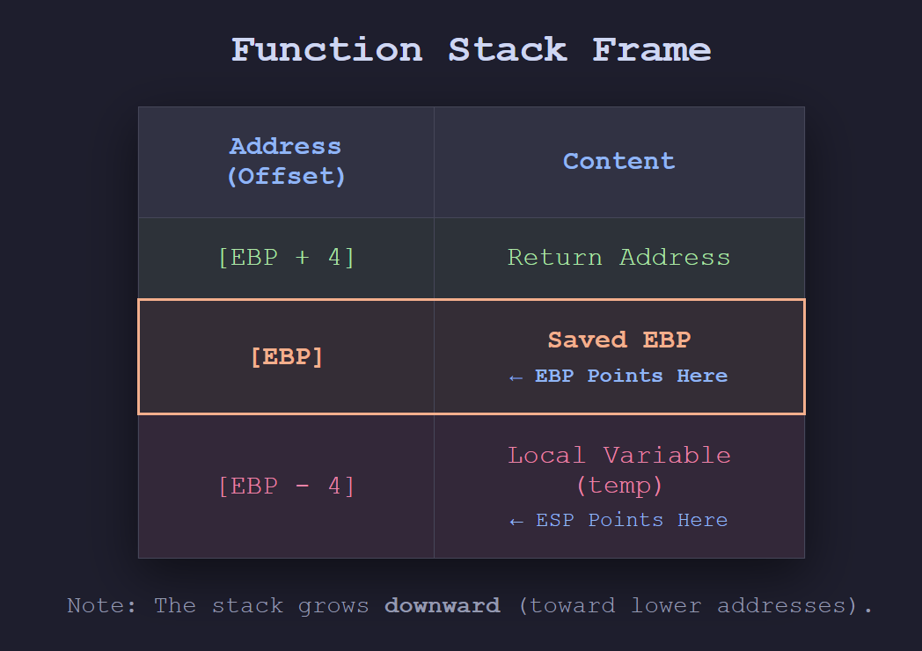

Microsoft x64 Calling Convention

The Microsoft x64 calling convention defines how functions pass parameters and return values in **64-bit Windows**:

1. **Parameter passing:**
   * First 4 parameters → RCX, RDX, R8, R9
   * Remaining parameters → pushed onto the stack (left-to-right)
2. **Return values:**
   * Integers ≤ 64 bits → RAX
   * Larger or complex types → placed on the stack; RCX points to the return location
3. **Stack requirements:**
   * At least 32 bytes of **shadow space** must be allocated by the caller
   * RSP must be **16-byte aligned** before a call
4. **Register preservation:**
   * Caller-saved (may be overwritten): RAX, RCX, RDX, R8, R9, R10, R11
   * Callee-saved (must be preserved by function): RBX, RBP, RDI, RSI, R12-R15
5. **CALL instruction:** subtracts 8 from RSP (64-bit address)

Understanding this is critical for writing **64-bit Windows programs** or calling Windows API functions.

Stack Frames and Parameters

**Subroutine Stack Frame**

A subroutine’s stack frame contains:

* Caller’s **return address**
* Subroutine’s **local variables**
* Optionally, saved registers

True/False Quiz Highlights:

1. **Stack frame always contains return address + locals → True**
2. **Arrays passed by reference to avoid copying → True**
3. **Prologue pushes EBP → True**
4. **Local variables created by adding positive value to ESP → True** (actually usually subtracting since stack grows down)
5. **Last argument at [EBP+8] in 32-bit → False** (correct: last argument is [EBP+4])
6. **Passing by reference stores argument’s address on the stack → True**

Stack Parameter Types

1. **Value parameters**
   * Copied onto the stack
   * Modifications inside function **do not affect caller**
2. **Reference parameters**
   * Address of variable stored on stack
   * Modifications inside function **affect caller**

C++ Example:



Value parameters are copied; reference parameters allow functions to modify caller’s variables directly.

✅ Takeaways:

* MASM uses push ebp / mov ebp, esp / sub esp, N for stack frames.
* leave and ret restore the stack and return.
* x64 calling conventions differ significantly from 32-bit, especially with registers.
* Know the difference between value vs reference parameters—they determine whether changes propagate back to the caller.

RECURSION IN ASSEMBLY LANGUAGE

* Recursion is a programming technique where a function calls itself directly or indirectly.
* It can be a powerful tool for solving complex problems, but it is important to understand how it works and how to avoid writing recursive functions that can cause stack overflows.

Endless Recursion:

* The example of endless recursion illustrates what can go wrong when recursion is not used correctly.
* The Endless procedure calls itself repeatedly without ever checking for a base case.
* As a result, the stack continues to grow until it overflows, causing the program to crash.

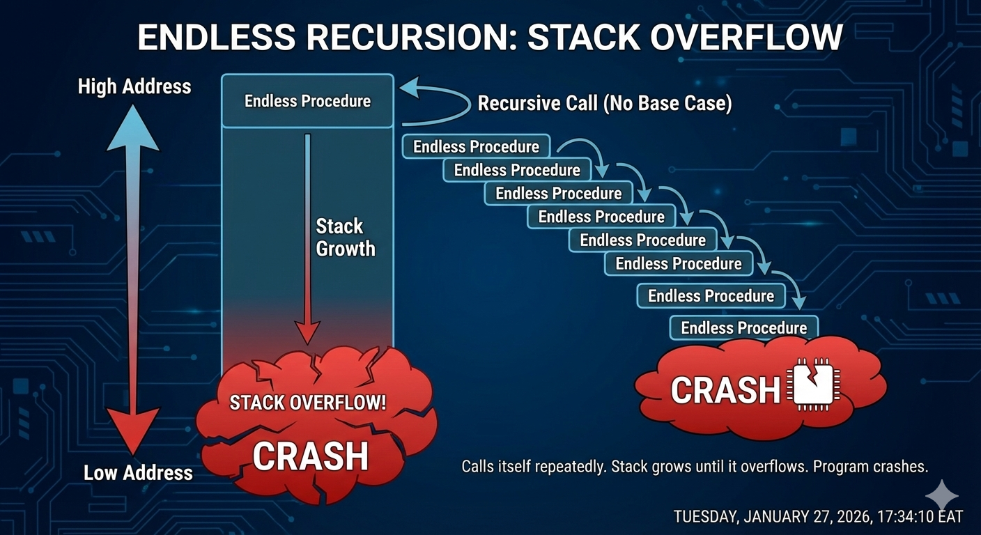

Correcting Endless Recursion:

* To rewrite the Endless procedure correctly, a base case must be added.
* A base case is a condition that will cause the procedure to terminate instead of calling itself again.
* For the Endless procedure, a suitable base case could be: *"if the input is 0, then return"*.
* Including a base case prevents infinite recursion and ensures the program runs safely.

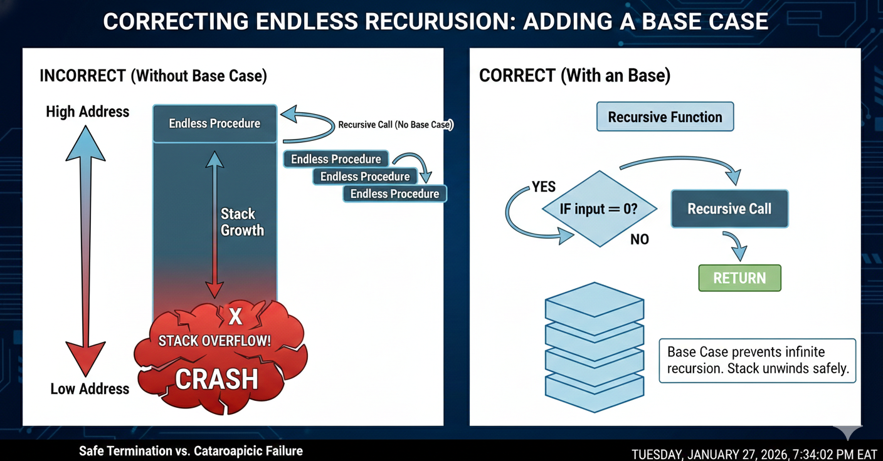

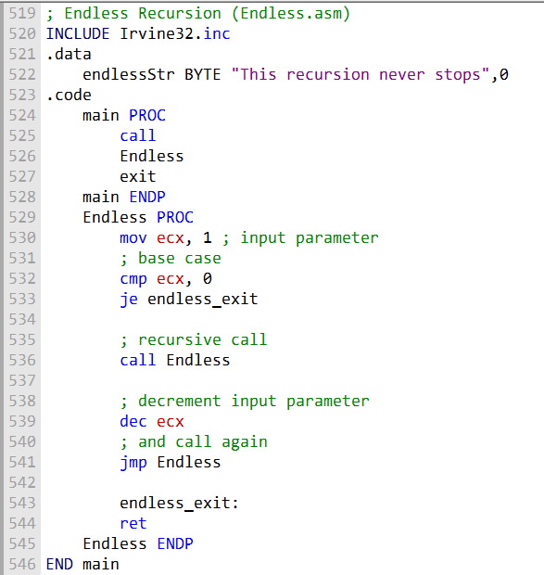

Here’s your text rewritten as bullet points:

* The rewritten version of the Endless procedure will terminate correctly when the input is 0.
* Before terminating, it will print the message: *"This recursion never stops"* to the console.

When to Use Recursion:

* Recursion is not suitable for all problems; it can be inefficient and difficult to debug.
* Recursion is a powerful tool for solving problems with repeating patterns.
* It is commonly used in algorithms for traversing linked lists and trees.
* Before using recursion, ensure that the problem is a good fit for a recursive solution.
* Carefully design recursive functions to avoid stack overflows and infinite recursion.

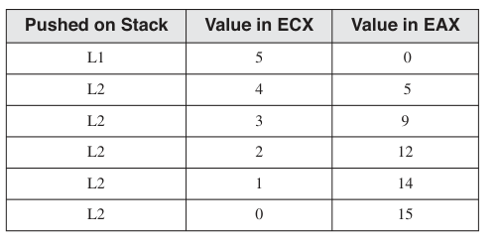

Recursively Calculating a Sum:

* A recursive procedure is one that calls itself.
* Recursion is useful for solving problems that can be broken down into smaller subproblems of the same type.
* To calculate the sum of integers from 1 to n, a recursive procedure can be used.

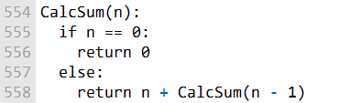

The procedure works by:

* Recursively calling itself to calculate the sum of integers from 1 to n - 1.
* Adding n to the result of that recursive call.

The **base case** occurs when n == 0, in which case the sum is 0.

The following table illustrates a **stack trace** for the recursive call CalcSum(5).

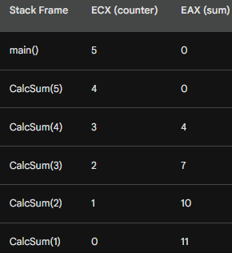

**Stack Frame Behavior:**

* Each recursive call pushes a stack frame onto the stack.
* The stack frame contains the **return address**, which is the address of the next instruction to execute after the call returns.

**Registers:**

* **ECX** contains the counter value for the current recursive call.
* **EAX** contains the sum of integers calculated so far.

**Recursive Call Flow:**

* First recursive call: CalcSum(5) calls CalcSum(4)
  + ECX = 4, EAX = 0
  + The program calculates the sum of integers from 1 to 4 recursively.
* Second recursive call: CalcSum(4) calls CalcSum(3)
  + ECX = 3, EAX = 0
  + The program calculates the sum of integers from 1 to 3 recursively.
* This continues until the **base case** (n == 0) is reached, returning 0.

**Returning from Recursion:**

* The program returns from CalcSum(0) to CalcSum(1), then to CalcSum(2), and so on.
* By the time it returns from CalcSum(5), the sum of integers from 1 to 5 is stored in **EAX**.
* The program can then return this sum from the main() function.

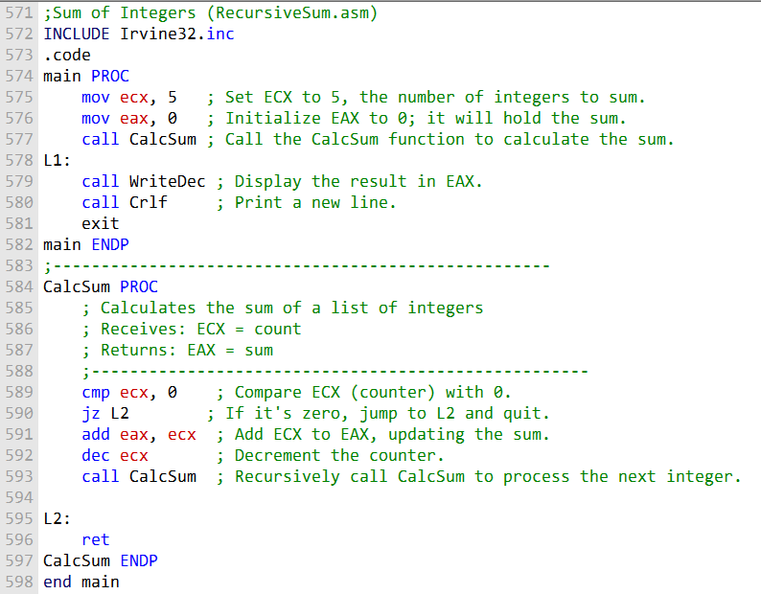

Main Procedure and CalcSum Explanation

* The main procedure initializes:
  + **ECX** to 5, representing the number of integers to sum.
  + **EAX** to 0, which will store the running total (sum).
* It then calls the CalcSum procedure to compute the sum.
* After the calculation:
  + The result is printed using WriteDec.
  + A new line is added using Crlf.
* **CalcSum Procedure:**
  + CalcSum is a recursive procedure that calculates the sum of integers.
  + It checks whether **ECX** (the counter) is zero.
  + If ECX is not zero:
    - The current value of ECX is added to **EAX**.
    - ECX is decremented.
    - CalcSum calls itself recursively.
  + This process continues until ECX reaches 0.
  + When ECX is 0, the procedure returns using ret.

Factorial of an Integer

* The Factorial procedure uses recursion to calculate the factorial of a number.
* It receives one stack parameter, **N**, which is the value whose factorial is to be calculated.
* The return address of the calling program is automatically pushed onto the stack by the CALL instruction.
* **Stack Frame Setup:**
  + Factorial first pushes **EBP** onto the stack to save the caller’s base pointer.
  + It then sets **EBP** to point to the beginning of the current stack frame.
  + This setup allows access to parameters and local variables using base-offset addressing.
* **Base Case:**
  + The base case occurs when **N = 0**.
  + In this case, Factorial returns **1**, since the factorial of 0 is 1.
* **Recursive Case:**
  + If **N ≠ 0**, Factorial calls itself recursively with **N − 1**.
  + This continues until the base case is reached.
* **Returning from Recursion:**
  + After returning from the recursive call, the procedure multiplies the returned value by **N**.
  + This follows the definition: *factorial(N) = N × factorial(N − 1)*

Example Stack Trace

The following table shows a stack trace for a call to Factorial(3):

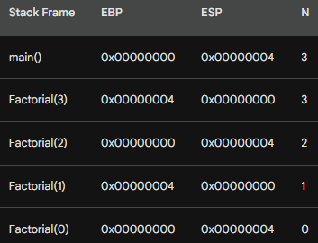

Explanation of the Stack and Recursive Calls (Factorial)

* A stack frame for each recursive call is pushed onto the stack when the CALL instruction is executed.
* Each stack frame contains:
  + The return address (the next instruction to execute after the call returns)
  + The saved base pointer (EBP)
  + The parameter **N**
* **Registers:**
  + **EBP** contains the base pointer for the current stack frame.
  + **ESP** contains the stack pointer, which points to the top of the stack.
  + **N** is a parameter stored on the stack and accessed using base-offset addressing (e.g., [EBP + 8]).
  + **EAX** is used to store the return value of the function.

Recursive Execution Flow

* **First call: Factorial(3)**
  + A new stack frame is created.
  + EBP is set to the start of the current stack frame.
  + The parameter N is set to 3.
  + The base case (N == 0) is checked and fails.
  + Factorial calls itself with N - 1 → Factorial(2).
* **Second call: Factorial(2)**
  + A new stack frame is created.
  + EBP is updated to the new stack frame.
  + The parameter N is set to 2.
  + The base case is checked and fails.
  + Factorial calls itself with N - 1 → Factorial(1).
* This process continues until **Factorial(0)** is reached.

Base Case and Returning

* **Base case:**
  + When N == 0, Factorial returns **1**.
  + The value 1 is placed in the **EAX** register.
* **Returning from recursion:**
  + Returning to Factorial(1):
    - EAX = 1
    - Multiply EAX by N (1) → result remains 1
  + Returning to Factorial(2):
    - EAX = 1
    - Multiply EAX by N (2) → result is 2
  + Returning to Factorial(3):
    - EAX = 2
    - Multiply EAX by N (3) → result is 6

Final Result

* The program returns to main().
* The **EAX register contains 6**, which is the factorial of 3.

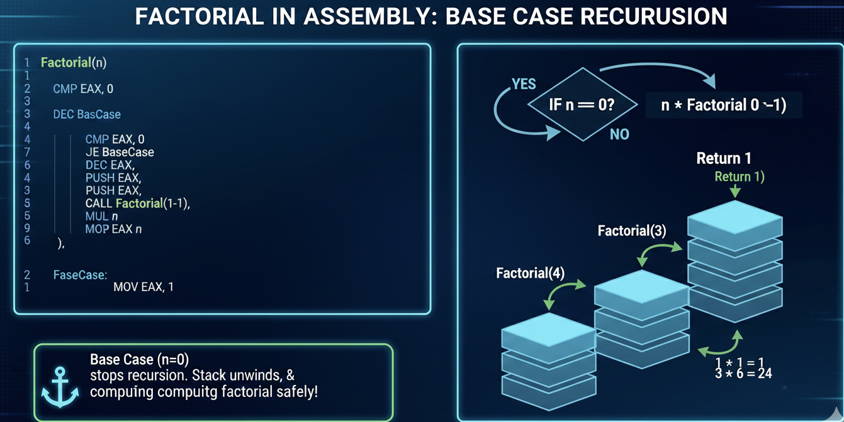

Step-by-Step Explanation of the Factorial Assembly Code

* The main procedure:
  + Pushes the initial value (5) onto the stack.
  + Calls the Factorial procedure to compute the factorial.
  + Receives the result in **EAX** and displays it.
* The Factorial procedure:
  + Is a recursive function that computes the factorial of an integer.
  + Saves the caller’s base pointer by pushing **EBP** onto the stack.
  + Sets up a new stack frame by moving **ESP** into **EBP**.
  + Retrieves the parameter n from the stack into **EAX**.
  + Compares n to 0 using the cmp instruction.
    - If n > 0, execution jumps to label **L1**.
    - If n == 0, execution jumps to label **L2** (base case).
* **Recursive Case (L1):**
  + Decrements n.
  + Pushes n − 1 onto the stack.
  + Calls Factorial recursively.
  + After returning, multiplies the returned value in **EAX** by n.
* **Base Case (L2):**
  + Occurs when n == 0.
  + Returns 1 in **EAX**.
  + Restores **EBP** and returns to the caller.
* This recursive process continues until n reaches 0.
* The final result is accumulated in **EAX** and returned to main.
* For input 5, the program correctly computes **5! = 120**.

Important Tip

When writing recursive procedures, it is crucial to:

* Track which registers are modified.
* Save and restore registers when their values must persist across recursive calls.

Failure to do so can corrupt data and cause incorrect results.

Questions and Answers

1. True / False

* **Statement:** Given the same task, a recursive subroutine usually uses more memory than a nonrecursive one.
* **Correct Answer:** ✅ **True**
* **Explanation:**
  + Recursive subroutines require additional stack space for:
    - Return addresses
    - Saved base pointers
    - Parameters
  + Each recursive call adds a new stack frame.

2. What condition terminates the recursion in the Factorial function?

* The recursion terminates when the input parameter **n equals 0**.

3. Which instructions execute after each recursive call finishes?

The instructions that:

* Multiply the value returned in **EAX** by n.

This follows the definition:

* **factorial(n) = n × factorial(n − 1)**

4. What happens if you try to calculate 13!?

* The program will **overflow**.
* **Reason:**
  + 13! = 6,227,020,800
  + This value exceeds the maximum value of a 32-bit signed integer.
* The result stored in **EAX** will be incorrect due to integer overflow.

Challenge Question: Stack Space Usage (Corrected)

*How many bytes of stack space would be used by the Factorial procedure when calculating 5!?*

**❌ Original claim: *20 bytes per call, total 100 bytes***

This is **incorrect**.

**✅ Correct Explanation:**

* Each recursive call uses:
  + **4 bytes** → return address
  + **4 bytes** → saved EBP
  + **4 bytes** → parameter n
* **Total per call:** **12 bytes**
* For Factorial(5):
  + Calls made: Factorial(5), (4), (3), (2), (1), (0) → **6 calls**
  + **Total stack usage:**
    - 12 bytes × 6 calls = 72 bytes

✅ **Correct answer: 72 bytes of stack space**

INVOKE, ADDR, PROC AND PROTO

**Advanced Procedure Directives (INVOKE, PROC, PROTO)**

* The **INVOKE**, **PROC**, and **PROTO** directives provide powerful tools for defining and calling procedures in 32-bit mode.
* These directives are more convenient to use than traditional CALL and PROC instructions.
* However, they **mask the underlying structure of the runtime stack**, which can make it harder to understand what is happening at a low level.
* The **PROTO** directive:
  + Allows the assembler to validate procedure calls.
  + Checks argument lists against procedure declarations.
  + Helps prevent errors and makes programs more robust.
* Advanced procedure directives:
  + Improve program readability and maintainability.
  + Are especially useful when procedures are called across module boundaries.
  + Abstract away low-level stack management details.

**Important Considerations**

* Because advanced directives hide stack mechanics:
  + Programmers should develop a solid understanding of how subroutine calls work internally.
  + This includes knowledge of stack frames, parameter passing, and return addresses.

**Recommendation**

* If you are new to assembly language:
  + Start by learning traditional CALL and PROC directives.
* After gaining a strong understanding of low-level subroutine mechanics:
  + Use advanced procedure directives to improve code clarity and maintainability.

INVOKE Directive (32-bit Assembly)

The INVOKE directive is a high-level MASM feature used to call procedures in 32-bit mode.

It allows you to pass multiple arguments to a procedure using a single, readable statement, instead of manually pushing each argument.

General Syntax

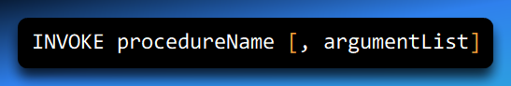

* **procedureName**: Name of the procedure being called
* **argumentList**: Optional, comma-separated list of arguments

Valid Argument Types

Arguments passed to INVOKE can be **any valid expression**, including:

Immediate values

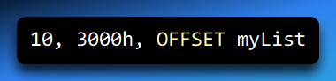

Integer expressions

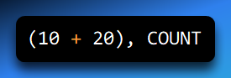

Variables

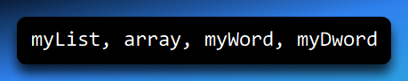

Address expressions

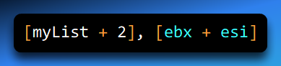

Registers

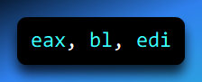

**Argument Order (Very Important)**

Arguments in an INVOKE statement are **pushed onto the stack in reverse order**, just like standard 32-bit calling conventions (cdecl, stdcall).

**Example: Calling DumpArray**

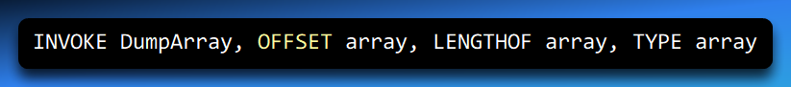

This pushes the arguments in this order:

1. TYPE array (element size)
2. LENGTHOF array (number of elements)
3. OFFSET array (address of array)

Then the procedure is called.

**Equivalent Low-Level Code**

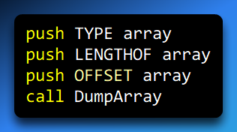

✅ INVOKE just saves you from writing this manually.

**Multiline INVOKE (Readable Style)**

You can split arguments across multiple lines to improve clarity:

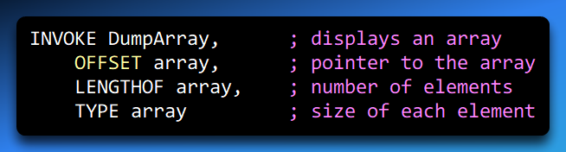

This is **purely a style choice**—both forms compile to the same machine code.

**Important Considerations**

**1. Register Side Effects (EAX & EDX)**

When passing arguments **smaller than 32 bits** (BYTE or WORD), MASM may:

* **Widen the value to 32 bits**
* Use **EAX and EDX internally**
* Overwrite their contents

**How to avoid problems:**

* Pass **32-bit arguments**, OR
* Save and restore registers:

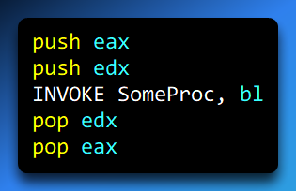

**2. 32-bit Only**

⚠️ The INVOKE directive:

* Works **only in 32-bit mode**
* Is **not used in x64**, where parameters are passed in registers

**Summary**

* INVOKE is a **convenient, readable way** to call procedures
* Arguments are pushed **right-to-left**
* Supports many argument types
* May overwrite **EAX/EDX** when widening small arguments
* Available **only in 32-bit MASM**

✅ **Final Takeaway:**  
Use INVOKE for clean, readable procedure calls in 32-bit assembly—but always be aware of argument size and register side effects.

**ADDR Operator (32-bit MASM)**

The ADDR operator is used with the INVOKE directive to **pass addresses (pointers)** to procedures in **32-bit mode**. It is essentially a **clean, readable shortcut** for passing OFFSET values when calling procedures.

**Key Characteristics**

* ✅ **32-bit only**
* ✅ **Used only with INVOKE**
* ✅ Returns the **address** of its operand
* ❌ Cannot be used with MOV, CALL, or other instructions
* ❌ Operand must be known at **assembly time**

**Syntax**

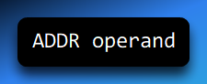

* operand must be an **assembly-time constant**
* Examples of valid operands:
  + Labels
  + Static arrays
  + Fixed memory addresses

**Basic Example**

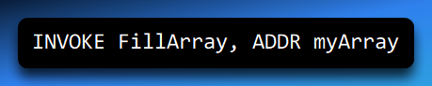

This passes the **address of myArray** to FillArray.

**Equivalent Code (Manual Version)**

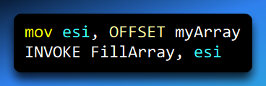

✅ The ADDR version is shorter, clearer, and preferred.

**Important Restrictions**

**1. Only Works with INVOKE**

❌ Invalid:

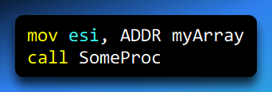

✅ Valid:

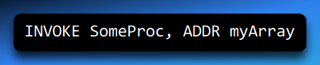

**2. Assembly-Time Constants Only**

You **cannot** use ADDR with values computed at runtime.

❌ Invalid:

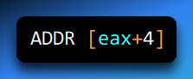

✅ Valid:

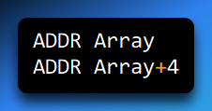

**Passing Multiple Addresses (Example)**

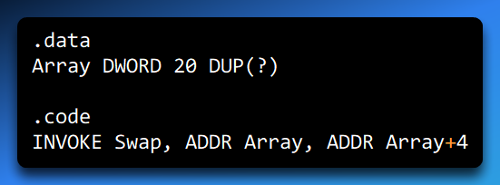

So ADDR is just a **clean wrapper around OFFSET pushes**.

**ADDR vs OFFSET (Quick Comparison)**

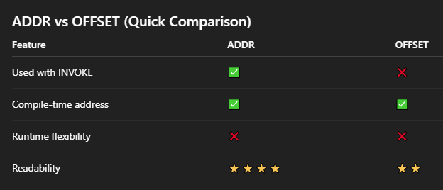

**Passing Function Addresses (Callbacks)**

ADDR can also be used to pass the **address of a procedure** to another procedure (useful for callbacks).

**Example**

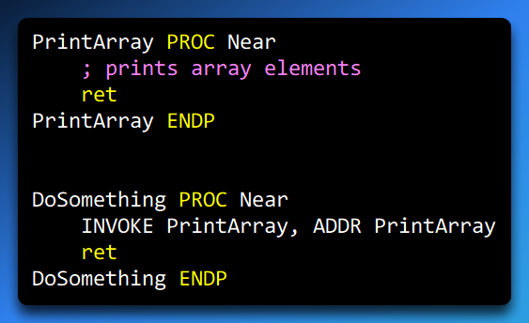

Here, ADDR PrintArray passes the **address of the function itself**.

**Summary**

* ADDR is a **high-level helper** for passing pointers using INVOKE
* It expands to push OFFSET ... behind the scenes
* Only works in **32-bit MASM**
* Improves readability and reduces boilerplate
* Perfect for arrays, structures, and callback-style designs

✅ **Final takeaway:**  
If you’re using INVOKE and need to pass a pointer to something known at assembly time, **ADDR is the cleanest and safest choice**.

**PROC Directive (32-bit MASM)**

The PROC directive is used to **define a procedure** in 32-bit assembly language. It tells the assembler where a procedure begins and allows you to specify **parameters, calling conventions, register usage, and visibility**.

**General Syntax**

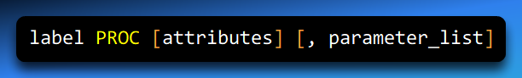

* **label**  
  User-defined name of the procedure (must follow identifier rules).
* **attributes** *(optional)*  
  Control how the procedure behaves.
* **parameter_list** *(optional)*  
  Declares named parameters passed to the procedure.

**PROC Attributes**

**1. Distance**

Specifies how the procedure is called:

* NEAR – same code segment (most common)
* FAR – different segment (rare in modern code)

**2. Language Type (Calling Convention)**

Specifies the **parameter passing convention**, such as:

* C (cdecl)
* STDCALL
* PASCAL

This affects:

* Argument order
* Stack cleanup responsibility
* Name decoration

**3. Visibility**

Controls whether the procedure is visible outside the module:

* PUBLIC – accessible from other modules
* PRIVATE – only accessible within the same module

**4. Prologue/Epilogue Arguments**

Used to control or customize stack frame generation (advanced usage).

**Declaring Parameters**

Parameters are declared directly in the PROC line using:

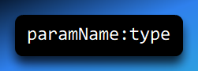

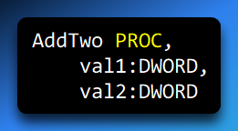

* Parameters are automatically placed on the stack
* They are accessed using symbolic names instead of [ebp+8], [ebp+12]

**USES Clause**

The USES clause tells MASM **which registers the procedure will modify**.

MASM automatically:

* Pushes these registers at the start of the procedure
* Pops them before returning

**Syntax**

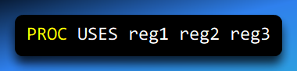

Example

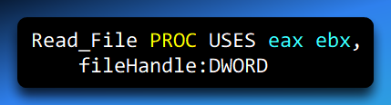

This means:

* EAX and EBX are preserved
* Caller state remains intact
* No manual push / pop needed

**Full Example**

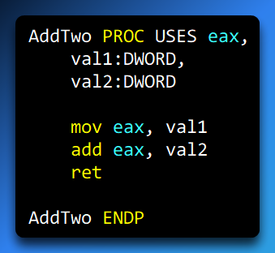

**What MASM Generates Automatically**

* Stack frame setup
* Parameter access logic
* Register preservation (eax)
* Clean, consistent epilogue

**Why PROC Is Powerful**

* Named parameters → **readable code**
* USES → **automatic register saving**
* Calling convention support
* Works seamlessly with INVOKE

**Summary**

* PROC defines a procedure in 32-bit MASM
* Supports parameters, calling conventions, and visibility
* USES automatically preserves registers
* Eliminates manual stack and register bookkeeping
* Designed to work cleanly with INVOKE

If you’re writing structured 32-bit MASM, PROC + parameters + USES is the cleanest, safest, and most maintainable way to define procedures.

The following example shows a simple procedure named AddTwo():

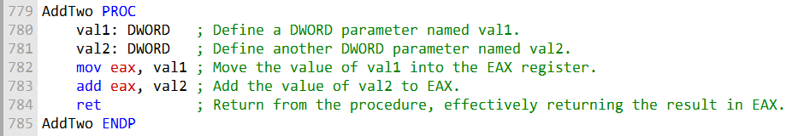

This procedure takes two doublewords as parameters and returns their sum.

The following shows the assembly code generated by MASM when assembling the AddTwo() procedure:

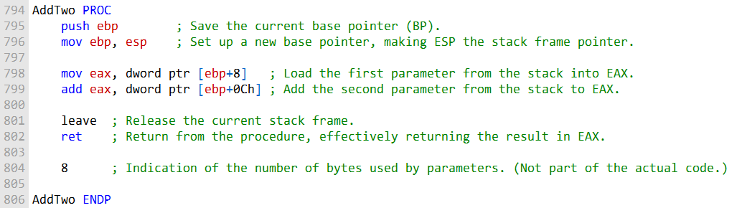

1. The first two lines save the old **EBP** value and set **EBP** to the current stack pointer.
   * This creates a stack frame for the procedure.
2. The next lines copy the function parameters from the stack into registers.
   * The first parameter goes into **EAX**.
   * The second parameter is read from the stack later.
3. The code adds the second parameter to the value in **EAX**.
   * The result stays in **EAX**.
4. The **leave** instruction restores the old stack frame.
   * It puts the old **EBP** back and resets **ESP**.
5. The **ret** instruction exits the procedure.
   * The value in **EAX** is returned.
6. The number **8** at the end means the parameters use 8 bytes total.
   * Each parameter is 4 bytes (32-bit).
7. The **PROC** directive helps define procedures in 32-bit mode.
   * It supports named parameters and manages the stack frame.

Instruction details:

1. push ebp
   * Saves the previous base pointer on the stack.
2. mov ebp, esp
   * Sets up a new base pointer for this procedure.
3. mov eax, [ebp+8]
   * Loads the first parameter from the stack into **EAX**.
4. add eax, [ebp+0Ch]
   * Adds the second parameter to **EAX**.
5. leave
   * Cleans up the stack frame and restores **EBP**.
6. ret
   * Returns from the procedure using the value in **EAX**.

Specifying the Parameter Passing Protocol

A **parameter passing protocol** (calling convention) defines **how arguments are passed**, **who cleans up the stack**, and **how procedures return values**. Common protocols include **C (cdecl)**, **STDCALL**, and **Pascal**.

In MASM, you specify the calling convention using the **attributes field** of the PROC directive.

**Syntax**

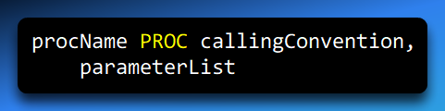

The calling convention controls:

* Argument order
* Stack cleanup responsibility
* Name decoration
* Compatibility with high-level languages

**C Calling Convention (cdecl)**

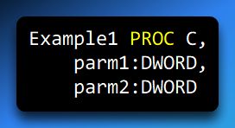

**Key characteristics:**

* Arguments pushed **right-to-left**
* **Caller** cleans up the stack
* Commonly used by **C/C++**
* Allows variable argument functions (e.g., printf)

When called using INVOKE, MASM generates code consistent with the **C calling convention**.

**STDCALL Calling Convention**

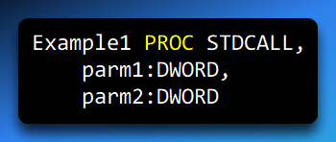

**Key characteristics:**

* Arguments pushed **right-to-left**
* **Callee** cleans up the stack
* Used extensively by the **Windows API**
* Fixed number of parameters

When called using INVOKE, MASM generates code consistent with **STDCALL**.

**Full Examples**

**Using C Calling Convention**

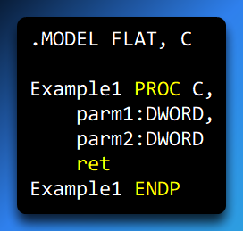

Using STDCALL Calling Convention

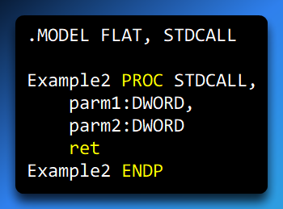

**Why This Matters**

* Ensures **binary compatibility** with C/C++ and Windows API functions
* Prevents **stack corruption**
* Allows assembly procedures to be safely called from high-level languages
* Makes INVOKE generate correct push/cleanup code automatically

**Summary**

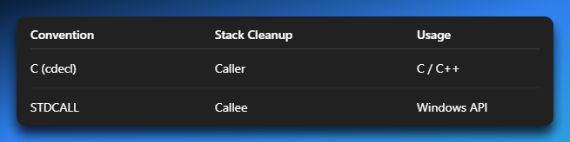

✅ **Final takeaway:**  
Specifying the parameter passing protocol using the PROC directive is essential for writing **safe, interoperable assembly code** that works correctly with other languages and libraries.

PROTO Directive in 32-bit Mode

The **PROTO directive** is used to **declare a procedure prototype** in MASM. A prototype specifies a procedure's name, parameter list, and optionally the calling convention, allowing you to:

* Call a procedure **before its definition**
* **Verify** that the number and types of arguments match the procedure
* Enable safer and more readable code when using INVOKE

Syntax

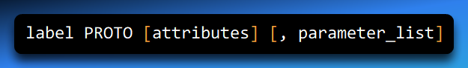

* **label** – Name of the procedure
* **attributes** – Optional; specifies the calling convention (C, STDCALL, etc.)
* **parameter_list** – Optional; defines parameters with types

**Example: ArraySum Prototype**

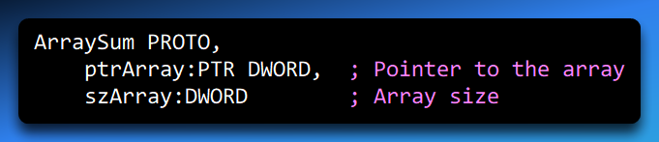

This declares that ArraySum takes:

1. A **pointer to an array** of doublewords
2. The **size of the array**

**Calling a Procedure with INVOKE**

Once a prototype is declared, you can safely call the procedure:

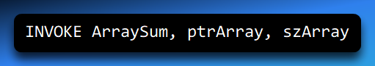

* INVOKE automatically pushes the arguments in the correct order
* Checks that the **number and types** of arguments match the prototype

This eliminates many common errors, such as stack misalignment or incorrect argument types.

**Important Notes**

1. Every procedure called with INVOKE **must have a prototype**.
2. The prototype must appear **before the procedure is called**.
3. The **parameter types and number** in the prototype must match the actual procedure definition.
4. PROTO improves **code readability, maintainability, and safety**.

PROTO allows assembly programs to **declare procedure interfaces ahead of time**, enabling safer, cleaner, and more modular code, especially when combined with INVOKE.

ASSEMBLY TIME ARGUMENT CHECKING

The **PROTO directive** allows MASM to perform **assembly-time argument checking**. This helps verify:

* The **number** of arguments passed to a procedure
* The **types** of arguments (to a limited extent)

⚠️ MASM is **less strict than C/C++**. It checks basic types and number of arguments but won’t catch every type mismatch.

**Example Prototype**

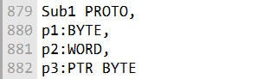

* Sub1 expects **three arguments**:
  1. A **byte**
  2. A **word** (2 bytes)
  3. A **pointer to a byte**

**Valid INVOKE Call**

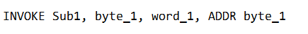

The assembler will generate the following code for this INVOKE statement:

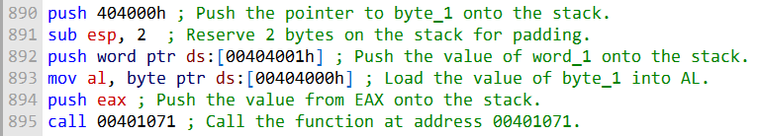

The assembler pads the stack with two bytes because the second argument (word_1) is a word, which is two bytes long.

1. push 00404000h → Pushes the pointer (p3)
2. sub esp, 2 → Padding for alignment
3. push word ptr ds:[00404001h] → Push 2-byte word (p2)
4. mov al, byte ptr ds:[00404000h] → Load 1-byte value (p1)
5. push eax → Push as DWORD
6. call 00401071 → Call the procedure

Errors Detected by MASM

1. Argument exceeds declared size

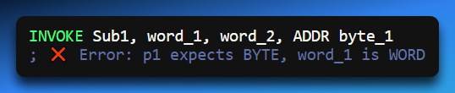

2. Too few or too many arguments

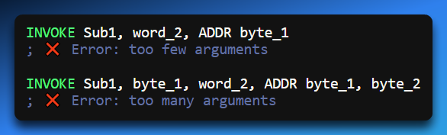

**Errors NOT Detected by MASM**

MASM **does not detect smaller arguments**. It will **expand smaller types** to the expected parameter size.

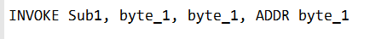

Instead, MASM will expand the smaller argument (byte_1) to the size of the declared parameter (WORD).

MASM expands byte_1 to match p2:WORD

Generates code:

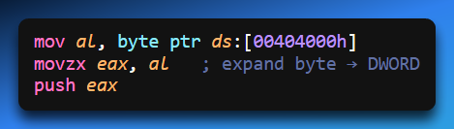

✅ MASM ensures stack consistency but may silently widen arguments.

In the following code generated by MASM, the second argument (byte_1) is expanded into EAX before pushing it on the stack:

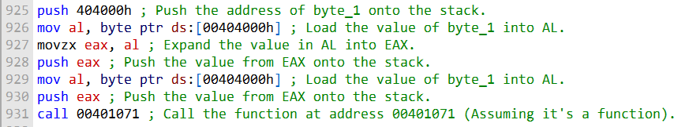

**Key Points**

* PROTO + INVOKE helps **catch argument mismatches** at assembly time.
* MASM checks: **number of arguments** & **basic type size**
* MASM **does not catch all type errors**, e.g., smaller types are expanded.
* Stack padding ensures **alignment** when pushing arguments of different sizes.

ArraySum

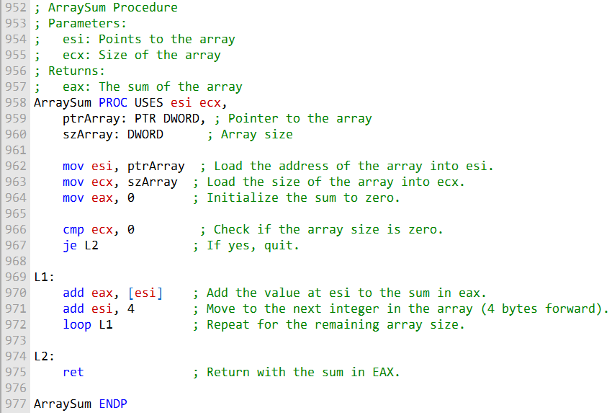

**ArraySum()** takes two parameters:

* A pointer to the array (address of the first element).
* The size of the array (number of elements).

The procedure uses registers:

* **ESI** to hold the array pointer.
* **ECX** to hold the array size.
* **EAX** will hold the running sum of the elements.

**Steps of the procedure:**

1. Set **EAX** to 0 (start the sum at zero).
2. Check if the array size (**ECX**) is zero.
   * If zero, return immediately.
3. Otherwise, enter a loop:
   * Add the value pointed to by **ESI** to **EAX**.
   * Move **ESI** to the next element in the array.
   * Repeat until all elements are added.
4. After the loop, **EAX** contains the total sum.
5. Return from the procedure.

**Result:**

* **EAX** holds the sum of all elements in the array.

**Example of calling ArraySum():**

* You pass the array pointer and its size as arguments.
* After the procedure, **EAX** will have the sum.

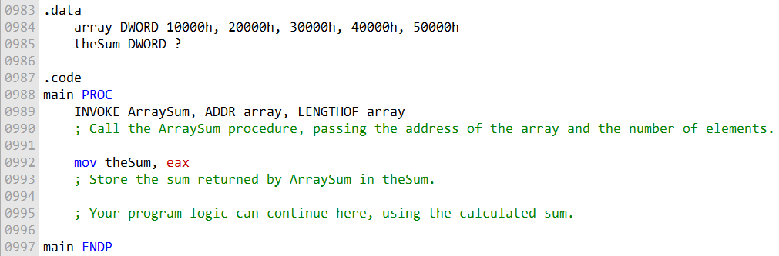

The **INVOKE** statement calls the **ArraySum()** procedure.

It passes two arguments:

* The address of the array.
* The number of elements in the array.

The **LENGTHOF** operator calculates the number of elements in the array automatically.

After **ArraySum()** finishes, the total sum of the array elements is stored in the **theSum** variable.

This example shows how to use:

* The **PROC** directive to define procedures with stack parameters.
* The **INVOKE** directive to call procedures and pass arguments via the stack.

**Key point:** Using **PROC** and **INVOKE** makes procedure calls cleaner and safer, especially when working with parameters.

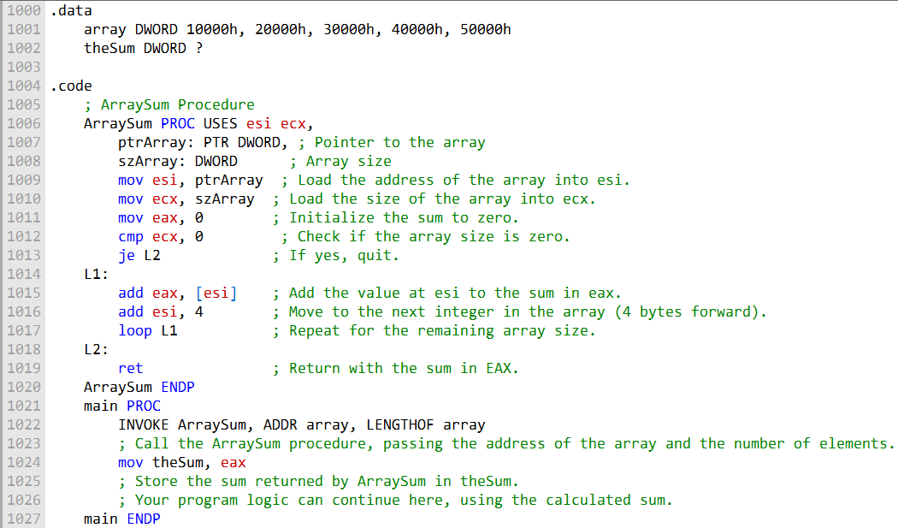

**.data Section**

* An array named **array** is defined with **5 DWORD (32-bit) elements** and initial values.
* A DWORD variable named **theSum** is declared with a **question mark**, meaning it is **uninitialized**.

**.code Section – ArraySum Procedure**

* **ArraySum** calculates the sum of a DWORD array.
* It expects **two parameters**:
  1. **ptrArray** – a pointer to the array.
  2. **szArray** – the number of elements in the array.

**Inside ArraySum:**

**ESI** holds the array address.

**ECX** stores the array size.

**EAX** is set to **0** and will accumulate the sum.

The code checks if the array size is **0**.

If zero, it jumps to **L2**, effectively quitting the procedure.

**Loop (L1):**

* Add the value at the address in **ESI** to **EAX**.
* Increment **ESI** by 4 to move to the next DWORD.
* Repeat for all elements using the **loop** instruction.

**End of procedure (L2):** Return with the sum in **EAX**.

**Main Procedure**

* Calls **ArraySum** using the **INVOKE** directive.
  + Passes **address of array** and **number of elements (LENGTHOF array)** as arguments.
* Stores the result returned in **EAX** into **theSum**.
* The program can continue using the sum stored in **theSum**.

**Parameter Classifications**

* **Input Parameters:**
  + Passed **from the calling program to the procedure**.
  + Procedure can use the data but **cannot change it**.
  + Example: reading an array to calculate a sum.
* **Output Parameters:**
  + Passed **from the procedure back to the calling program**.
  + Procedure can **change the value**, and the calling program will see the updated data.
  + Example: returning the sum of the array elements.

**Key Points:**

* **ArraySum** efficiently calculates the sum of an array and returns it in **EAX**.
* **INVOKE** and **PROC** make procedure calls and parameter passing easier in assembly.
* Using **ESI, ECX, and EAX** keeps track of the array, its size, and the running sum.

Here is an example of an input parameter:

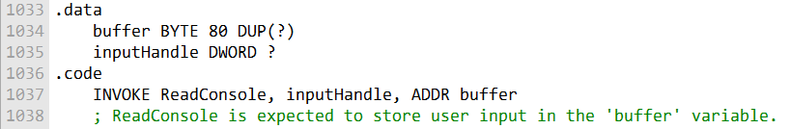

and

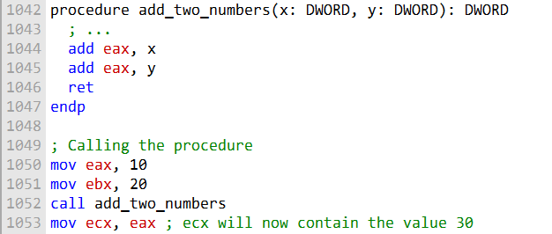

* In the **add_two_numbers()** example:
  + **x** and **y** are **input parameters**.
  + The procedure **reads** their values to calculate a sum.
  + It **does not change** x or y.
* **Output parameters** are different:
  + They are used to **return data** from the procedure to the calling program.
  + The procedure **can change** the value of an output parameter.
  + The calling program will see the updated value after the procedure returns.

Example of an output parameter:

A procedure that calculates the sum of two numbers and stores it in a variable provided by the caller.

* Caller passes a **pointer or variable** to hold the result.
* Procedure updates that variable directly.

Here is an example of an output parameter:

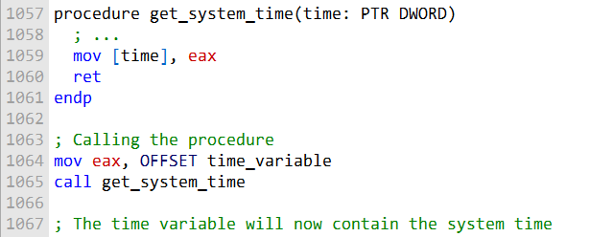

In this example:

* **time** is an **output parameter**.
* The procedure **get_system_time()** uses the pointer in **time** to store the system time in the memory location the pointer points to.

**Input and output parameters can be used together** in a procedure.

* Example: A procedure could take an **input parameter** for the size of an array and use an **output parameter** to return the sum of the array elements.

**Input/output parameters**:

* Example: a **buffer** (a block of memory for temporary storage).
* A procedure can take a buffer as an input/output parameter to:
  + Read data into the buffer from a file (input).
  + Return the data to the calling program (output).
  + Optionally, modify the data and return the updated version (input/output).

**Key idea:**

**Input parameters** provide data to the procedure.

* **Output parameters** return data from the procedure.
* **Input/output parameters** allow the procedure to both read and update data in the same memory location.

Here is an example of how to use an input/output parameter in assembly language:

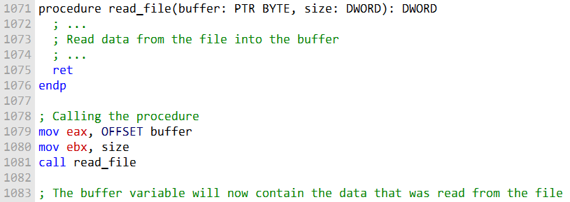

In this example:

* **buffer** is an **input/output parameter**.
* The procedure **read_file()** reads data from a file into the buffer.
* The procedure can also **modify the buffer**, so the calling program receives the updated data.

**Additional output:**

* **read_file()** returns the **number of bytes read** from the file.
* The calling program can use this to know how much valid data is in the buffer.

**Key idea:**

* Input/output parameters let the procedure **both read and update** data in the same memory location.
* Procedures can also return additional information (like the number of bytes read) through the **return value** or another output parameter.

**Next example: Exchanging Two Integers**

* This is another example of using **input/output parameters**.
* A procedure can **swap two numbers** by taking pointers to the integers as parameters and modifying their values directly.

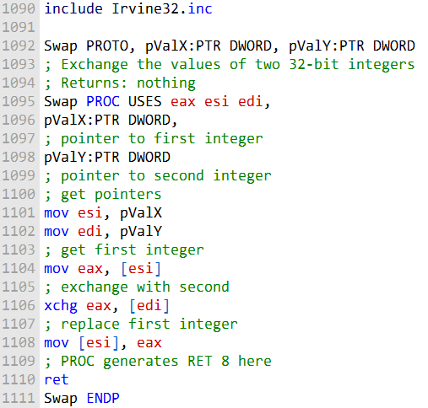

**Swap procedure:**

* Takes **two input/output parameters**: pValX and pValY.
* These parameters are **pointers** to the two integers that need to be swapped.

**Steps inside Swap:**

1. Get the pointers to the two integers.
2. Load the value of the first integer into **EAX**.
3. Use **XCHG** to exchange the value in **EAX** with the second integer.
4. Store the value in **EAX** back into the first integer.

**Return behavior:**

* Swap does **not return a value**.
* Ends with a **RET** instruction.
* Because it uses the **STDCALL calling convention**, the **PROC directive generates RET 8**, which cleans up the two parameters from the stack.

**Calling Swap:**

* It can be called from the main procedure by passing the **addresses of the two integers** as arguments.

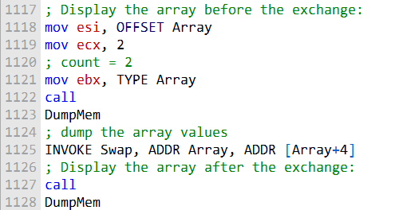

**Calling Swap:**

* The **INVOKE** statement calls the Swap procedure.
* It passes the **addresses of the first two elements** of the array.
* After the procedure returns, the **first two elements are swapped**.

**Limitations / missing checks:**

* Swap does **not check for invalid addresses**.
  + If a pointer is incorrect, the program may **crash**.
* Swap is **not optimized for speed**.
  + Using a temporary variable could make swapping slightly faster.

**Key takeaway:**

* Swap is a **simple example of input/output parameters** in assembly.
* It demonstrates **how a procedure can directly modify data** in memory through pointers.

Debugging Tips for Procedure Calls

1. Argument Size Mismatch

Make sure the arguments you pass to a procedure are the **correct size**.

* Example: If a procedure expects a **doubleword pointer**, pass a **doubleword pointer**.
* Passing a smaller pointer, like a **word pointer**, will prevent the procedure from accessing the data correctly.

**Example:**

* Swap() expects **two doubleword pointers**.
* If you pass **two word pointers**, the procedure cannot access the integers correctly.
* This may cause incorrect results or program crashes.

Here is an example of an argument size mismatch:

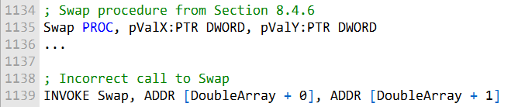

2. Passing the Wrong Type of Pointer

Make sure the arguments are the **correct type** of pointer.

* Example: If a procedure expects a **doubleword pointer**, do **not** pass a **byte pointer**.
* Using the wrong type of pointer prevents the procedure from reading/writing memory correctly.

**Example:**

* Swap() expects **DWORD pointers**.
* Passing a **BYTE pointer** will cause memory access errors.

Here is an example of passing the wrong type of pointer:

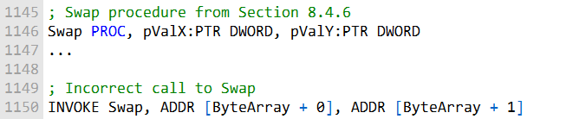

3. Wrong Pointer Size

* Swap() expects **two doubleword pointers**.
* Passing **two byte pointers** instead will prevent the procedure from accessing the integers correctly.
* This can cause **incorrect results or crashes**.

4. Passing Immediate Values to Reference Parameters

* **Reference parameters** expect a **pointer to a variable**, not the value itself.
* If you pass an **immediate value** (like 5) instead of a pointer, the procedure cannot access memory correctly.
* This will lead to **errors or crashes**.

Small note:

* Always pass the **correct pointer type and size** for reference parameters.
* Never pass an immediate value to a parameter that expects a pointer.

Here is an example of passing an immediate value to a reference parameter:

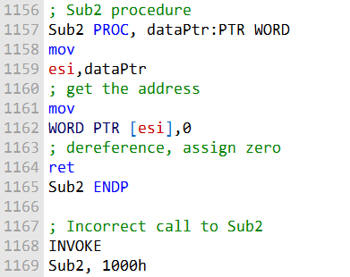

5. Passing Immediate Values to Reference Parameters

* Sub2() expects **a pointer to a word** as its only parameter.
* Passing an **immediate value** instead will prevent the procedure from accessing memory correctly.
* This can cause **crashes or incorrect results**.

6. General Advice

* Always be careful when **passing arguments** to procedures in assembly.
* Check the **procedure documentation** to confirm:
  + The **number of parameters**
  + The **type of each parameter**
  + The **size of each parameter**
* Mistakes can lead to **program crashes or wrong results**.

Short note:

* Always pass **pointers** for reference parameters.
* Never pass immediate values where a pointer is expected.
* Confirm argument type, size, and count before calling a procedure.

WIRESTACKFRAME PROCEDURE

WriteStackFrame and WriteStackFrameName (Irvine32 Library)

WriteStackFrame:

* A procedure from the **Irvine32 library**.
* Displays the **contents of the current procedure’s stack frame**.
* Shows details like:
  + **Stack parameters** (arguments passed to the procedure)
  + **Return address**
  + **Local variables**
  + **Saved registers**

WriteStackFrameName:

* Similar to **WriteStackFrame**, but also displays the **name of the procedure** whose stack frame is being shown.

Usefulness:

* Helps **debug and visualize the stack**.
* Makes it easier to **understand how parameters, local variables, and registers are stored**.
* Very helpful when learning or troubleshooting **stack behavior in assembly programs**.

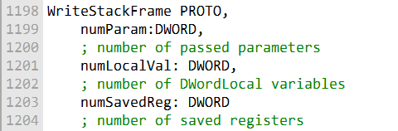

WriteStackFrame Procedure (Irvine32 Library)

Displays the **contents of the current procedure’s stack frame**.

* Shows:
  + Stack parameters
  + Return address
  + Saved registers
  + Local variables

Parameters (3):

**numParam** – Number of parameters passed to the procedure.

Determines how many DWORDs to display at the **top of the stack**.

**numLocalVal** – Number of DWORD local variables for the procedure.

**numSavedReg** – Number of registers saved on the stack. Typically 2 (for **EAX** and **EBX**).

How it displays the stack:

Starts at **EBP** and moves downward toward **ESP**.

For each DWORD, shows:

* Offset from **EBP**
* Hex value stored there

Order of display (from higher to lower offsets):

* Parameters (highest offsets)
* Return address
* Saved EBP
* Local variables
* Saved registers

Stops when reaching **ESP** (last used stack location).

WriteStackFrameName Procedure

Works like **WriteStackFrame**, but with an extra parameter:

* **procName** – Pointer to a null-terminated string with the procedure’s name.
* Displays the **procedure name** at the top of the output.
* Useful when **multiple procedures call WriteStackFrame/WriteStackFrameName**.

Summary / Usefulness

Let’s you **see the contents of the stack** at any point in a procedure.

Helps debug issues with:

* Stack parameters
* Local variables
* Saved registers
* Return addresses

Great for understanding **stack behavior in assembly programs**.

Here is an explanation of the MASM code example that was shown in the original text:

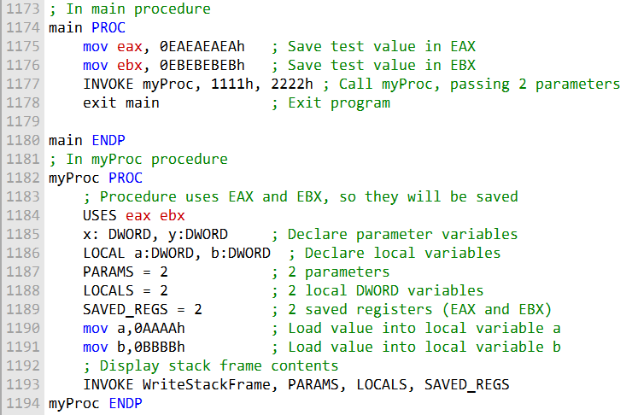

The following sample output was produced by the call:

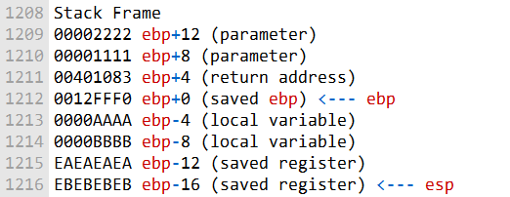

A second procedure, named WriteStackFrameName, has an additional parameter that holds the name of the procedure owning the stack frame:

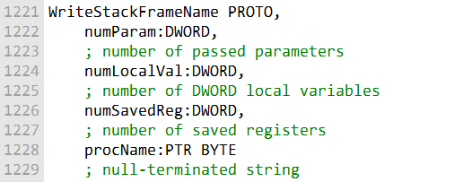

Like WriteStackFrame, but takes an extra parameter:

* **procName** – the name of the procedure owning the stack frame.

Displays the procedure name at the top of the stack output.

Main Procedure Example

* Loads sample values into **EAX** and **EBX** to be saved on the stack later.
* Calls **myProc** with **two DWORD arguments**: 1111h and 2222h.
* Exits the program after the call.

myProc Procedure

Uses **EAX** and **EBX** registers (so they will be saved on the stack).

Declares **x and y parameters** and **a and b local variables**.

Loads sample values into the local variables.

Calls **WriteStackFrame**, passing:

* + 2 – number of parameters
  + 2 – number of local DWORD variables
  + 2 – number of saved registers (EAX and EBX)

Displayed Stack Contents

The procedure’s stack frame shows:

* Parameters: 1111h and 2222h
* Return address back to **main**
* Saved **EBP** from **main**
* Local variables: a and b
* Saved registers: **EAX** and **EBX**

Purpose:

* Demonstrates how WriteStackFrame helps visualize a procedure’s stack usage.
* Useful for understanding stack layout, parameter passing, local variables, and saved registers.

Additional Info

* Irvine32 library source code can be found in:  
  \Examples\Lib32\Irvine32.asm (usually C:\Irvine)

MULTIMODULE PROGRAMS

A large program can be divided into multiple modules (assembled units) to make it easier to manage and assemble. Each module is assembled independently, so a change to one module's source code only requires reassembling the single module. The linker combines all assembled modules (OBJ files) into a single executable file.

***There are two general approaches to creating multimodule programs:***

**Traditional approach:**

Using the EXTERN directive to declare external procedures and the PUBLIC directive to export procedures to other modules. Microsoft's advanced INVOKE and PROTO directives: simplify procedure calls and hide some low-level details.

**Hiding and Exporting Procedure Names**

By default, MASM makes all procedures public, permitting them to be called from any other module in the same program.

You can override this behavior using the PRIVATE qualifier or the OPTION PROC:PRIVATE directive.

**PRIVATE qualifier:** makes a single procedure private.

**OPTION PROC:PRIVATE directive:** makes all procedures in a module private by default.

You can use the PUBLIC directive to export any procedures you want.

If you use OPTION PROC:PRIVATE in your program's startup module, be sure to designate your startup procedure (usually main) as PUBLIC, or the operating system's loader will not be able to find it.

The following example shows how to create a multimodule program using the traditional approach:

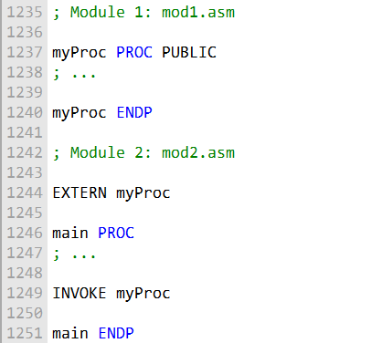

To assemble the program, you would use the following commands:

This would create an executable file called myprog.exe.

The EXTERN directive tells the assembler that the myProc() procedure is defined in another module.

The PUBLIC directive tells the assembler that the myProc() procedure can be called from other modules.

**Using the INVOKE and PROTO Directives**

The following example shows how to create a multimodule program using Microsoft's advanced INVOKE and PROTO directives:

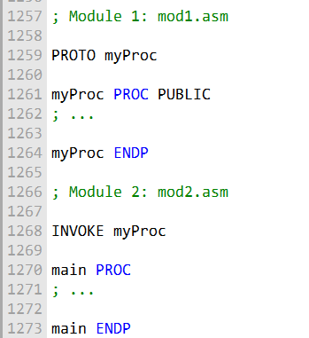

To assemble the program, you would use the following commands:

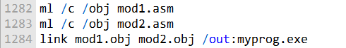

This would create an executable file called myprog.exe.

The **/c option** tells MASM to compile the source code but not link it. The **/obj option** tells MASM to generate object files. The **/out: option** tells MASM to generate an executable file with the specified name.

The PROTO directive tells the assembler about the prototype of the myProc() procedure, including its name and the number and types of its arguments.

The INVOKE directive tells the assembler to call the myProc() procedure.

The INVOKE and PROTO directives simplify procedure calls and hide some low-level details, such as the need to push and pop arguments on the stack.

CALLING EXTERNAL PROCEDURES

To call an external procedure in MASM, you use the EXTERN directive.

The EXTERN directive tells the assembler that the procedure is defined in another module and gives the procedure's name and stack frame size.

The following example shows how to call an external procedure named sub1():

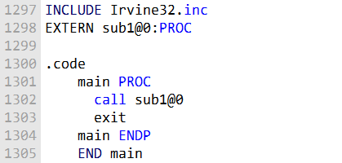

The **@0 suffix** at the end of the procedure name indicates that the procedure **does not have any parameters.**

If the procedure has parameters, you must include the **stack frame size** in the EXTERN directive.

The stack frame size is the total amount of stack space that the procedure uses to store its parameters and local variables.

The following example shows how to call an external procedure named AddTwo(), which has two doubleword parameters:

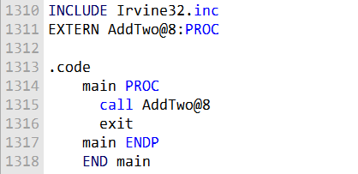

The @8 suffix at the end of the procedure name indicates that the procedure uses 8 bytes of stack space for its parameters.

You can also use the PROTO directive in place of the EXTERN directive. The PROTO directive tells the assembler about the prototype of the procedure, including its name and the number and types of its arguments.

The following example shows how to use the PROTO directive to declare the prototype of the AddTwo() procedure:

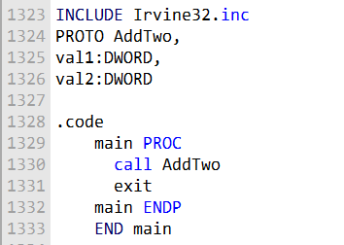

The PROTO directive tells the assembler that the AddTwo() procedure has two doubleword parameters.

When the assembler sees a call to the AddTwo() procedure, it can check to make sure that the correct number of arguments are passed to the procedure.

The EXTERN and PROTO directives are both used to call external procedures.

The EXTERN directive is simpler to use, but the PROTO directive provides more information to the assembler, which can help to prevent errors.

***Which directive should you use?***

If you are only calling a few external procedures and you are not concerned about the performance of your program, then you can use the EXTERN directive.

If you are calling a large number of external procedures or if you are concerned about the performance of your program, then you should use the PROTO directive.

The PROTO directive provides more information to the assembler, which can help to optimize the code.

***======================================================***

***Using Variables and Symbols across Module Boundaries:***

***Exporting Variables and Symbols***

***======================================================***

**What is EXTERNDEF?**

EXTERNDEF is a directive that combines the functionality of the PUBLIC and EXTERN directives. It can be used to export variables and symbols from one module and import them into another module.

**How to use EXTERNDEF?**

To use EXTERNDEF, you first need to create an include file that contains the EXTERNDEF declarations for the variables and symbols that you want to share. For example, the following include file defines two variables, count and SYM1:

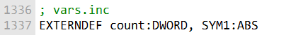

Then, you can include the include file in any module that needs to access the variables or symbols. For example, the following module exports the count and SYM1 variables:

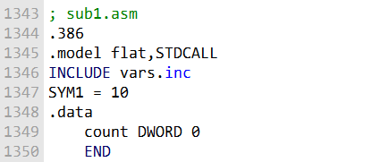

Finally, you can import the variables or symbols into any module that needs to use them. For example, the following module imports the count and SYM1 variables and uses them to calculate a value:

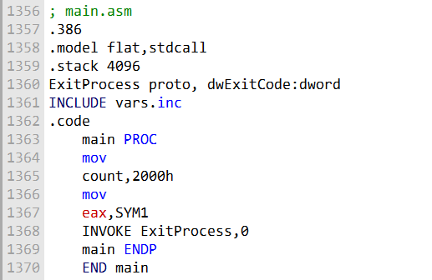

**Benefits of using EXTERNDEF**

There are several benefits to using EXTERNDEF to share variables and symbols across module boundaries:

It makes it easy to share variables and symbols between modules. It helps to reduce the amount of duplicate code.

It makes the code more modular and reusable. Conclusion

EXTERNDEF is a powerful directive that can be used to share variables and symbols across module boundaries.

It is a good practice to use EXTERNDEF to share variables and symbols between modules, as it makes the code more modular and reusable.

Let's make our program modular and see these concepts in action:

***==========================***

***ArraySum program***

***==========================***

The ArraySum program, first presented in Chapters before, is a good example of a multimodule program. The program can be divided into the following modules:

**main.asm:** The startup module, which calls the other modules to perform the program's tasks.

**promptforintegers.asm:** Prompts the user to enter an array of integers and reads the integers from the console.

**arraysum.asm:** Calculates the sum of the integers in the array.

**writeinteger.asm:** Writes an integer to the console.

The following diagram shows the structure chart of the ArraySum program:

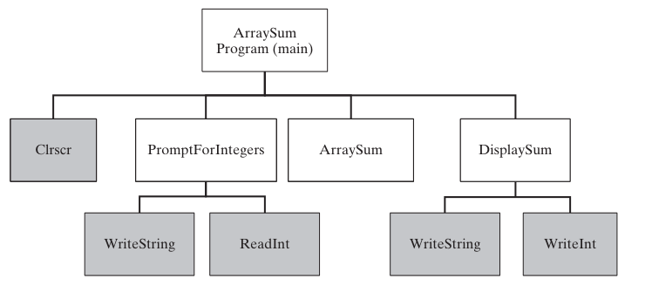

***==========================***

***Prompt for Integers***

***==========================***

; Prompt For Integers (_prompt.asm)  
INCLUDE Irvine32.**inc**  
.code  
 ;----------------------------------------------------  
 PromptForIntegers PROC  
 ; Prompts the user for an array of integers and fills  
 ; the array with the user's input.  
 ; Receives:  
 ; ptrPrompt: PTR BYTE - prompt string  
 ; ptrArray: PTR DWORD - pointer to array  
 ; arraySize: DWORD - size of the array  
 ; Returns: nothing  
 ;-----------------------------------------------------  
 arraySize EQU [ebp+16]  
 ptrArray EQU [ebp+12]  
 ptrPrompt EQU [ebp+8]  
 **enter** 0,0  
 **pushad**  
 ; save all registers  
 **mov** ecx,arraySize  
 **cmp** ecx,0  
 ; array size != 0?  
 **jle** L2  
 ; yes: quit  
 **mov** edx,ptrPrompt  
 ; address of the prompt  
 **mov** esi,ptrArray  
 L1:  
 **call** WriteString  
 ; display string  
 **call** ReadInt  
 ; read integer into EAX  
 **call** Crlf  
 ; go to next output line  
 **mov** [esi],eax  
 ; store in array  
 **add** esi,4  
 ; next integer  
 **loop** L1  
 L2:  
 **popad**  
 ; restore all registers  
 **leave**  
 **ret**  
 12  
 ; restore the stack  
 PromptForIntegers ENDP  
 end

The prompt.asm file contains the source code for the PromptForIntegers() procedure. This procedure prompts the user for an array of integers and fills the array with the user's input.

* The **PromptForIntegers()** procedure takes three parameters:
* • **• ptrPrompt:** A pointer to the prompt string.
* • **• ptrArray:** A pointer to the array.
* • **• arraySize:** The size of the array.

***The PromptForIntegers() procedure works as follows:***

It saves all of the registers.

It compares the array size to 0. If the array size is 0, the procedure exits. It displays the prompt string using the WriteString() procedure. It reads an integer from the console using the ReadInt() procedure. It stores the integer in the array.

It increments the array pointer. It repeats steps 3-6 until all of the integers have been read. It restores all of the registers. It leaves the procedure. Here is a more detailed explanation of each step:

**Step 1: Save all of the registers**

The PromptForIntegers() procedure saves all of the registers because it needs to use them and it does not want to overwrite any of the values that are in the registers when the procedure is called.

**Step 2: Compare the array size to 0**

The PromptForIntegers() procedure checks the array size to make sure that it is not 0. If the array size is 0, the procedure exits. This is because it does not make sense to prompt the user for an array of integers if the array is empty.

**Step 3: Display the prompt string**

The PromptForIntegers() procedure displays the prompt string using the WriteString() procedure. The WriteString() procedure is a library procedure that writes a string to the console.

**Step 4: Read an integer from the console**

The PromptForIntegers() procedure reads an integer from the console using the ReadInt() procedure. The ReadInt() procedure is a library procedure that reads an integer from the console and stores it in the EAX register.

**Step 5: Store the integer in the array**

The PromptForIntegers() procedure stores the integer in the array by moving the EAX register to the array element that is pointed to by the array pointer.

**Step 6: Increment the array pointer**

The PromptForIntegers() procedure increments the array pointer so that it points to the next element in the array.

**Step 7: Repeat steps 3-6 until all of the integers have been read**

The PromptForIntegers() procedure repeats steps 3-6 until all of the integers have been read. This is done by using the loop instruction. The loop instruction repeats a block of instructions until a specified condition is met. In this case, the condition is that the array pointer is not equal to the end of the array.

**Step 8: Restore all of the registers**

The PromptForIntegers() procedure restores all of the registers that it saved in step 1.

**Step 9: Leave the procedure**

The PromptForIntegers() procedure leaves the procedure by using the leave instruction. The leave instruction restores the stack frame and returns from the procedure.

The **PromptForIntegers() procedure** is a good example of how to write a procedure in assembly language. The procedure is well-structured and easy to understand. The procedure also uses library procedures to perform common tasks, such as writing a string to the console and reading an integer from the console.

**==========================**

**ArraySum program**

**==========================**

; ArraySum Procedure (_arraysum.asm)  
INCLUDE Irvine32.**inc**  
.code  
 ;-----------------------------------------------------  
 ArraySum PROC  
 ;  
 ; Calculates the sum of an array of 32-bit integers.  
 ; Receives:  
 ; ptrArray - pointer to array  
 ; arraySize - size of array (DWORD)  
 ; Returns: EAX = sum  
 ;-----------------------------------------------------  
 ptrArray EQU [ebp+8]  
 arraySize EQU [ebp+12]  
 **enter** 0,0  
 **push** ecx  
 ; don't push EAX  
 **push** esi  
 **mov** eax,0  
 ; set the sum to zero  
 **mov** esi,ptrArray  
 **mov** ecx,arraySize  
 **cmp** ecx,0  
 ; array size != 0?  
 **jle** L2  
 ; yes: quit  
 L1:  
 **add** eax,[esi]  
 ; add each integer to sum  
 **add** esi,4  
 ; point to next integer  
 **loop** L1  
 ; repeat for array size  
 L2:  
 **pop** esi  
 **pop** ecx  
 ; return sum in EAX  
 **leave**  
 **ret**  
 8  
 ; restore the stack  
 ArraySum ENDP  
 END

The code you provided is the implementation of the ArraySum() procedure in assembly language. The ArraySum() procedure calculates the sum of an array of 32-bit integers.

***The ArraySum() procedure takes two parameters:***

* ptrArray: A pointer to the array.
* arraySize: The size of the array.

***The ArraySum() procedure works as follows:***

It saves the ECX register, because it needs to use it and it does not want to overwrite the value that is in the register when the procedure is called. It sets the EAX register to 0.

This is because the EAX register will be used to store the sum of the integers in the array. It moves the pointer to the first element of the array into the ESI register. It compares the array size to 0.

If the array size is 0, the procedure exits. This is because it does not make sense to calculate the sum of an empty array.

It adds the integer at the current position in the array to the EAX register. It increments the ESI register so that it points to the next element in the array.

It repeats steps 5 and 6 until all of the integers in the array have been added to the EAX register. It restores the ECX register.

It leaves the procedure.

***Here is a more detailed explanation of each step:***

**Step 1: Save the ECX register**

The ArraySum() procedure saves the ECX register because it needs to use it and it does not want to overwrite the value that is in the register when the procedure is called.

**Step 2: Set the EAX register to 0**

The ArraySum() procedure sets the EAX register to 0 because it will be used to store the sum of the integers in the array.

**Step 3: Move the pointer to the first element of the array into the ESI register**

The ArraySum() procedure moves the pointer to the first element of the array into the ESI register. This is because the ESI register will be used to iterate through the array.

**Step 4: Compare the array size to 0**

The ArraySum() procedure checks the array size to make sure that it is not 0. If the array size is 0, the procedure exits. This is because it does not make sense to calculate the sum of an empty array.

**Step 5: Add the integer at the current position in the array to the EAX register**

The ArraySum() procedure adds the integer at the current position in the array to the EAX register. This is done using the add instruction. The add instruction adds two operands and stores the result in the first operand.

**Step 6: Increment the ESI register so that it points to the next element in the array**

The ArraySum() procedure increments the ESI register so that it points to the next element in the array. This is done using the inc instruction. The inc instruction increments the value of the operand by 1.

**Step 7: Repeat steps 5 and 6 until all of the integers in the array have been added to the EAX register**

The ArraySum() procedure repeats steps 5 and 6 until all of the integers in the array have been added to the EAX register.

This is done using the loop instruction. The loop instruction repeats a block of instructions until a specified condition is met.

In this case, the condition is that the ESI register is not equal to the value of the ptrArray parameter.

**Step 8: Restore the ECX register**

The ArraySum() procedure restores the ECX register.

Step 9: Leave the procedure

The ArraySum() procedure leaves the procedure by using the leave instruction. The leave instruction restores the stack frame and returns from the procedure.

The ArraySum() procedure is a good example of how to write a procedure in assembly language. The procedure is well-structured and easy to understand. The procedure also uses a loop to iterate through the array, which is a common technique in assembly language.

***==========================***

***Display Sum Proc***

***==========================***

; DisplaySum Procedure (_display.asm)  
INCLUDE Irvine32.**inc**  
.code  
 ;-----------------------------------------------------  
 DisplaySum PROC  
 ; Displays the sum on the console.  
 ; Receives:  
 ; ptrPrompt - offset of the prompt string  
 ; theSum - the array sum (DWORD)  
 ; Returns: nothing  
 ;-----------------------------------------------------  
 theSum EQU [ebp+12]  
 ptrPrompt EQU [ebp+8]  
 **enter** 0,0  
 **push** eax  
 **push** edx  
 **mov** edx,ptrPrompt  
 ; pointer to prompt  
 **call** WriteString  
 **mov** eax,theSum  
 **call** WriteInt  
 ; display EAX  
 **call** Crlf  
 **pop** edx  
 **pop** eax  
 **leave**  
 **ret**  
 8  
 ; restore the stack  
 DisplaySum ENDP  
 END

The code you provided is the implementation of the DisplaySum() procedure in assembly language. The DisplaySum() procedure displays the sum of an array of 32-bit integers on the console.

The DisplaySum() procedure takes two parameters:

* • **• ptrPrompt:** A pointer to the prompt string.
* • **• theSum:** The sum of the integers in the array. The DisplaySum() procedure works as follows:

It saves the EAX and EDX registers, because it needs to use them and it does not want to overwrite the values that are in the registers when the procedure is called. It moves the pointer to the prompt string into the EDX register.

It calls the WriteString() procedure to display the prompt string on the console. It moves the sum of the integers in the array into the EAX register.

It calls the WriteInt() procedure to display the sum of the integers in the array on the console.

It calls the Crlf() procedure to move the cursor to the next line on the console. It restores the EAX and EDX registers.

It leaves the procedure.

***Here is a more detailed explanation of each step:***

**Step 1: Save the EAX and EDX registers**

The DisplaySum() procedure saves the EAX and EDX registers because it needs to use them and it does not want to overwrite the values that are in the registers when the procedure is called.

**Step 2: Move the pointer to the prompt string into the EDX register**

The DisplaySum() procedure moves the pointer to the prompt string into the EDX register. This is because the EDX register will be used to pass the pointer to the prompt string to the WriteString() procedure.

**Step 3: Call the WriteString() procedure to display the prompt string on the console**

The DisplaySum() procedure calls the WriteString() procedure to display the prompt string on the console. The WriteString() procedure is a library procedure that writes a string to the console.

**Step 4: Move the sum of the integers in the array into the EAX register**

The DisplaySum() procedure moves the sum of the integers in the array into the EAX register. This is because the EAX register will be used to pass the sum of the integers in the array to the WriteInt() procedure.

**Step 5: Call the WriteInt() procedure to display the sum of the integers in the array on the console**

The DisplaySum() procedure calls the WriteInt() procedure to display the sum of the integers in the array on the console. The WriteInt() procedure is a library procedure that writes an integer to the console.

**Step 6: Call the Crlf() procedure to move the cursor to the next line on the console**

The DisplaySum() procedure calls the Crlf() procedure to move the cursor to the next line on the console. The Crlf() procedure is a library procedure that moves the cursor to the next line on the console.

**Step 7: Restore the EAX and EDX registers**

The DisplaySum() procedure restores the EAX and EDX registers.

**Step 8: Leave the procedure**

The DisplaySum() procedure leaves the procedure by using the leave instruction. The leave instruction restores the stack frame and returns from the procedure.

The DisplaySum() procedure is a good example of how to write a procedure in assembly language. The procedure is well-structured and easy to understand. The procedure also uses library procedures to perform common tasks, such as writing a string to the console and writing an integer to the console.

***==============***

***Sum_main.asm***

***=============***

; Integer Summation Program (Sum_main.asm)  
; Multimodule example:  
; This program inputs multiple integers from the user,  
; stores them in an array, calculates the sum of the  
; array, and displays the sum.  
INCLUDE Irvine32.**inc**  
INCLUDE macros.asm ; Include for INVOKE and PROTO  
  
EXTERN PromptForIntegers:PROC  
EXTERN ArraySum:PROC  
EXTERN DisplaySum:PROC  
  
; Modify Count to change the size of the array:  
Count = 3  
  
.data  
prompt1 BYTE "Enter a signed integer: ",0  
prompt2 BYTE "The sum of the integers is: ",0  
array DWORD Count DUP(?)  
sum DWORD ?  
  
.code  
main PROC  
 **call** Clrscr  
 ; PromptForIntegers(ADDR prompt1, ADDR array, Count)  
 INVOKE PromptForIntegers, ADDR prompt1, ADDR array, Count  
   
 ; sum = ArraySum(ADDR array, Count)  
 INVOKE ArraySum, ADDR array, Count  
 **mov** sum, eax  
   
 ; DisplaySum(ADDR prompt2, sum)  
 INVOKE DisplaySum, ADDR prompt2, sum  
 **call** Crlf  
 exit  
main ENDP  
  
END main

This code retains the same functionality as the original version but utilizes Microsoft's INVOKE and PROTO directives for calling procedures, making the code more structured and easier to read.

The code you provided is a multimodule example of an integer summation program. The program inputs multiple integers from the user, stores them in an array, calculates the sum of the array, and displays the sum.

***The program is divided into three modules:***

**Sum_main.asm:** This is the main module, which contains the main() procedure. The main() procedure is responsible for calling the other modules to perform the program's tasks.

**promptforintegers.asm:** This module contains the PromptForIntegers() procedure, which prompts the user for multiple integers and stores them in an array.

**arraysum.asm:** This module contains the ArraySum() procedure, which calculates the sum of the integers in an array.

**display.asm:** This module contains the DisplaySum() procedure, which displays the sum of the integers in an array on the console.

**The Sum_main.asm module is the main module of the program. The main() procedure in this module performs the following steps:**

It calls the Clrscr() procedure to clear the console screen. It calls the PromptForIntegers() procedure to prompt the user for multiple integers and store them in an array. It calls the ArraySum() procedure to calculate the sum of the integers in the array.

It calls the DisplaySum() procedure to display the sum of the integers in the array on the console. It calls the Crlf() procedure to move the cursor to the next line on the console. It calls the exit() procedure to exit the program.

The promptforintegers.asm module contains the PromptForIntegers() procedure. This procedure prompts the user for multiple integers and stores them in an array. The procedure takes the following parameters:

* • **• ptrPrompt:** A pointer to the prompt string.
* • **• ptrArray:** A pointer to the array.
* **Count:** The number of integers to prompt the user for.

***The PromptForIntegers() procedure works as follows:***

It iterates over the array and prompts the user for each integer. It stores the integer that the user enters in the array.

It repeats steps 1 and 2 until all of the integers have been entered. The arraysum.asm module contains the ArraySum() procedure. This procedure calculates the sum of the integers in an array. The procedure takes the following parameters:

* ptrArray: A pointer to the array.
* Count: The number of integers in the array.

***The ArraySum() procedure works as follows:***

It initializes the sum to 0.

It iterates over the array and adds each integer to the sum. It returns the sum. The display.asm module contains the DisplaySum() procedure.

This procedure displays the sum of the integers in an array on the console. The procedure takes the following parameters:

* • **• ptrPrompt:** A pointer to the prompt string.
* • **• theSum:** The sum of the integers in the array.

The DisplaySum() procedure works as follows:

It displays the prompt string on the console. It displays the sum of the integers in the array on the console. It moves the cursor to the next line on the console.

The integer summation program is a good example of how to use multiple modules to write a program. By dividing the program into modules, we can make the program more modular, reusable, and maintainable.

***=========================================***

***Creating Modules using INVOKE and PROTO***

***=========================================***

Creating the Modules Using INVOKE and PROTO section are the use of the INVOKE, PROTO, and PROC directives. These directives are used to create multimodule programs in 32-bit mode.

The INVOKE directive is used to call a procedure in another module. The PROTO directive is used to declare a prototype for a procedure. The PROC directive is used to define a procedure.

The following table shows the differences between the traditional use of CALL and EXTERN and the use of INVOKE, PROTO, and PROC:

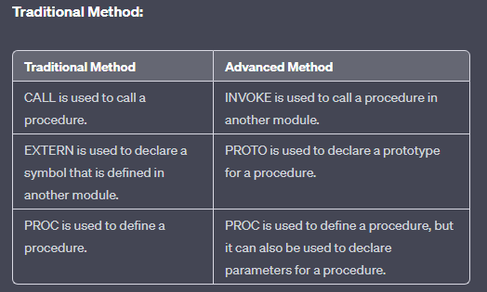

The **main advantage of using the INVOKE, PROTO, and PROC directives** is that they allow the assembler to match up the argument lists passed by INVOKE to the corresponding parameter lists declared by PROC. This helps ensure that the program is correct and that it does not crash.

Example Using INVOKE, PROTO, and PROC:

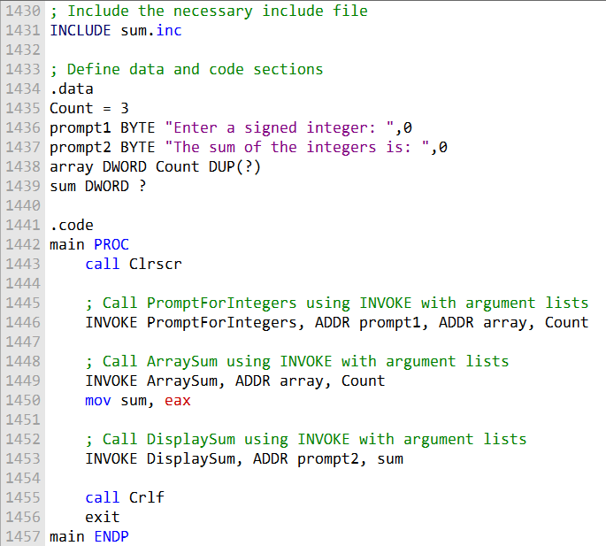

These are all the functions using advanced methods:

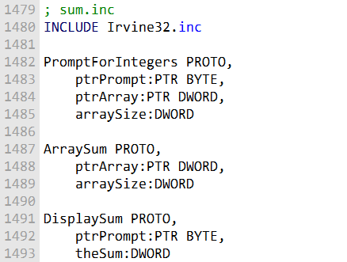

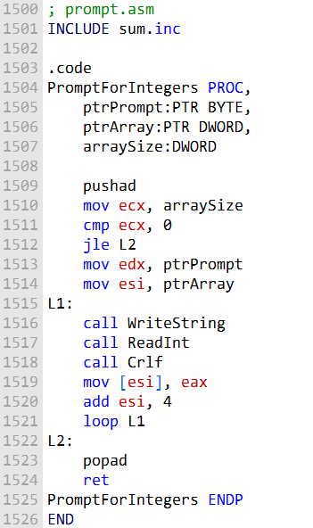

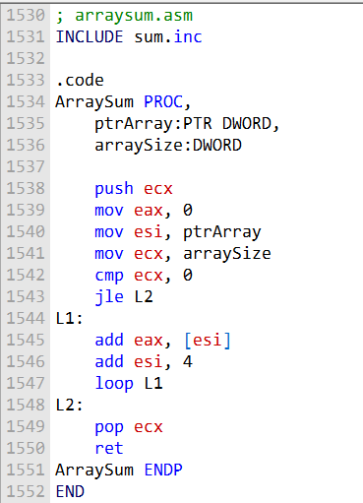



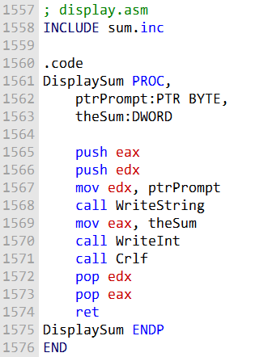

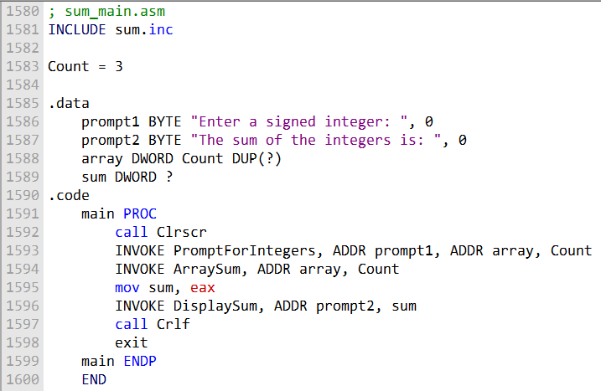

Here is a summary of the two ways to create multimodule programs:

**Traditional method:**

Use the EXTERN directive to declare symbols that are defined in another module. Use the CALL directive to call procedures in other modules.

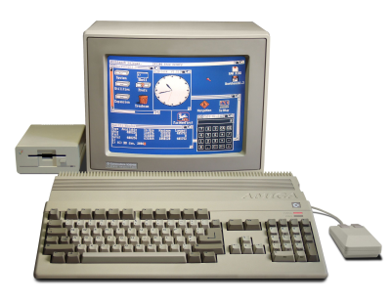

**Advanced method:**

Use the PROTO directive to declare prototypes for procedures in other modules. Use the INVOKE directive to call procedures in other modules. Use the PROC directive to define procedures, and declare parameters for procedures. The advanced method is simpler to use and more efficient, but it is only available in 32-bit mode.



**Conclusion:**

The advanced method is the preferred method for creating multimodule programs in 32-bit mode. It is simpler to use and more efficient than the traditional method. However, the traditional method is still supported, and it may be necessary for some programs.

ADVANCED OPTIONAL TOPIC 1 – USES OPERATOR

The USES operator is a powerful tool that can be used to save and restore registers at the beginning and end of a procedure.

However, it should not be used when declaring procedures that access their stack parameters using constant offsets such as [ebp + 8].

The following MySub1 procedure employs the USES operator to save and restore ECX and EDX:

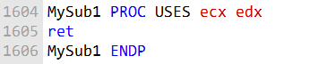

The following code is generated by MASM when it assembles MySub1:

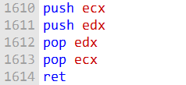

Suppose we combine USES with a stack parameter, as does the following MySub2 procedure. Its parameter is expected to be located on the stack at EBP+8:

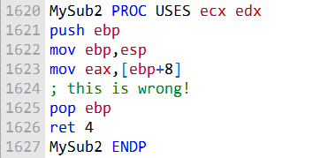

Here is the corresponding code generated by MASM for MySub2:

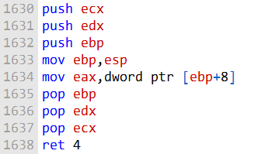

An error results because the assembler inserted the PUSH instructions for ECX and EDX at the beginning of the procedure, altering the offset of the stack parameter.

Figure 8-6 below shows how the stack parameter must now be referenced as [EBP+16]. USES modifies the stack before saving EBP, which corrupts the standard prologue code commonly used for subroutines.

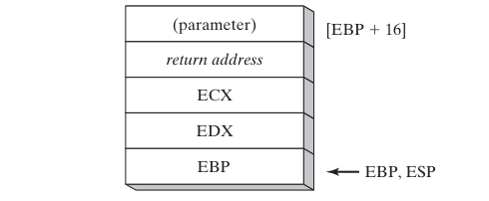

This is why it is important to avoid using the USES operator when declaring procedures that access their stack parameters using constant offsets.

If you need to save and restore registers in such a procedure, you can use the PUSH and POP instructions explicitly.

Here is a more in-depth explanation of why the USES operator causes problems in this case:

When a procedure is called, the caller pushes the procedure's arguments onto the stack.

The procedure then saves its caller-saved registers (EBP, ESI, EDI, and EBX) onto the stack. The procedure's base pointer (EBP) is set to point to the top of the stack frame.

The USES operator tells the assembler to save and restore the specified registers at the beginning and end of the procedure.

When the USES operator is used in a procedure that accesses its stack parameters using constant offsets, the assembler inserts the PUSH and POP instructions for the specified registers at the beginning and end of the procedure.

This corrupts the standard prologue code commonly used for subroutines, which relies on the stack pointer (ESP) to be pointing to the top of the stack frame.

In the example of MySub2, the USES operator is used to save and restore ECX and EDX. When MySub2 is called, its argument is pushed onto the stack.

The USES operator then causes the assembler to push ECX and EDX onto the stack. This corrupts the stack frame, because the stack pointer is now pointing to the wrong location.

To avoid this problem, you should not use the USES operator in procedures that access their stack parameters using constant offsets.

If you need to save and restore registers in such a procedure, you can use the PUSH and POP instructions explicitly.

PASSING 8-BIT AND 16-BIT ARGUMENTS ON THE STACK

***Passing 8-bit Arguments***

When passing stack arguments to procedures in 32-bit mode, it is best to push 32-bit operands.

This is because the stack pointer (ESP) must be aligned on a doubleword boundary.

If 16-bit operands are pushed onto the stack, ESP will not be aligned and a page fault may occur. Additionally, runtime performance may be degraded.

If you need to pass a 16-bit operand to a procedure in 32-bit mode, you can use the MOVZX instruction to expand the operand to 32 bits before pushing it onto the stack.

For example, the following Uppercase procedure receives a character argument and returns its uppercase equivalent in AL:

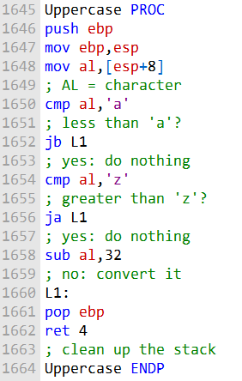

If we pass a character literal to Uppercase, the PUSH instruction will automatically expand the character to 32 bits:

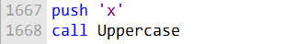

However, if we pass a character variable to Uppercase, the PUSH instruction will not allow us to push an 8-bit operand onto the stack.

To work around this, we can use the MOVZX instruction to expand the character into EAX before pushing it onto the stack:

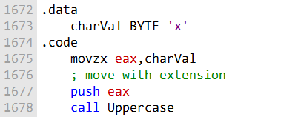

This will ensure that ESP is aligned on a doubleword boundary and that the call to Uppercase is successful.

***Passing 16-bit Arguments.***

The AddTwo procedure expects two 32-bit integer arguments (the two integers to be added). However, the word1 and word2 variables are 16-bit integers.

Therefore, if we push word1 and word2 onto the stack and call AddTwo, the procedure will not be able to correctly add the two integers.

To fix this, we can zero-extend each argument before pushing it onto the stack. Zero-extension means that the high-order 16 bits of the argument are set to zero.

This will effectively convert the 16-bit argument to a 32-bit argument.

The following code correctly calls AddTwo by zero-extending each argument before pushing it onto the stack:

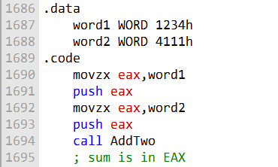

The **MOVZX instruction** is used to zero-extend the 16-bit word1 and word2 variables into the 32-bit EAX register.

Once the arguments have been zero-extended, they are pushed onto the stack in reverse order (word2 first, then word1).

When AddTwo is called, it will pop the two arguments off the stack and add them together. The sum of the two integers will be returned in the EAX register.

It is important to note that the caller of a procedure must ensure that the arguments it passes are consistent with the parameters expected by the procedure.

In the case of stack parameters, the order and size of the parameters are important.

If the caller passes the wrong number of arguments, or if the arguments are in the wrong order or have the wrong size, the procedure may not work correctly or may even crash.

***Passing 64-bit Arguments***

To pass 64-bit integer arguments to procedures in 32-bit mode, we must push the high-order doubleword of the argument first, followed by the low-order doubleword.

This is because the stack grows downwards, so the lower order doubleword of the argument will be at the lower address on the stack.

The following WriteHex64 procedure displays a 64-bit integer in hexadecimal:

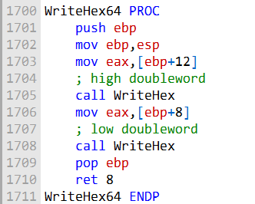

The following sample call to WriteHex64 pushes the upper half of longVal, followed by the lower half:

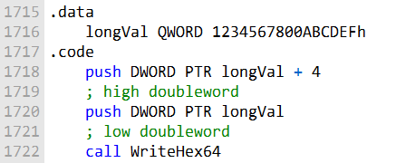

Figure below shows the stack frame inside WriteHex64 just after EBP was pushed on the stack and ESP was copied to EBP:

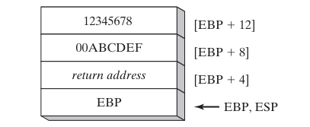

Or

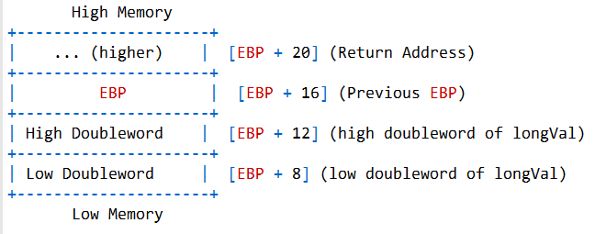

The WriteHex64 procedure can then easily retrieve the high and low doublewords of the argument from the stack and display them in hexadecimal.

It is important to note that the caller of a procedure must ensure that the arguments it passes are consistent with the parameters expected by the procedure.

In the case of stack parameters, the order and size of the parameters are important.

If the caller passes the wrong number of arguments, or if the arguments are in the wrong order or have the wrong size, the procedure may not work correctly or may even crash.

Here is a more in-depth explanation of why we must push the high-order doubleword of a 64-bit integer first when passing it to a procedure in 32-bit mode:

In 32-bit mode, the stack grows downwards. This means that when we push a value onto the stack, the stack pointer (ESP) is decremented.

When we pop a value off the stack, ESP is incremented.

When we pass a 64-bit integer to a procedure in 32-bit mode, we must push the high-order doubleword of the integer first, followed by the low-order doubleword.

This is because we want the integer to be stored on the stack in little-endian order.

In **little-endian order**, the low-order byte of the integer is stored at the lowest address on the stack.

If we were to push the low-order doubleword of the integer first, followed by the high-order doubleword, the integer would be stored on the stack in big-endian order.

In **big-endian order,** the high-order byte of the integer is stored at the lowest address on the stack.

The following diagram shows how a 64-bit integer is stored on the stack in little-endian order:

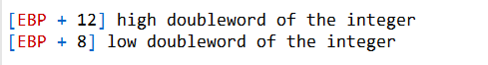

The WriteHex64 procedure can then easily retrieve the high and low doublewords of the integer from the stack and display them in hexadecimal.

Why is it important to ensure that the arguments passed to a procedure are consistent with the parameters expected by the procedure?

The caller of a procedure must ensure that the arguments it passes are consistent with the parameters expected by the procedure.

This is because the procedure is expecting certain values to be passed to it in a certain order.

If the caller passes the wrong number of arguments, or if the arguments are in the wrong order or have the wrong size, the procedure may not work correctly or may even crash.

For example, if the WriteHex64 procedure expects one 64-bit integer argument, and the caller passes two 64-bit integer arguments, the procedure will not be able to correctly display the two integers.

Or, if the caller passes a 32-bit integer argument instead of a 64-bit integer argument, the procedure will also not be able to correctly display the integer.

It is important to note that the compiler will not check to make sure that the caller is passing the correct number of arguments to a procedure, or that the arguments are in the correct order or have the wrong size. This is the responsibility of the programmer.

***Non-Doubleword Local Variables***

In 32-bit mode, the stack grows downwards. This means that when we push a value onto the stack, the stack pointer (ESP) is decremented.

When we pop a value off the stack, ESP is incremented.

When we declare a local variable in a procedure, MASM will allocate space for it on the stack. The size of the space allocated will depend on the size of the variable.

For example, if we declare a byte variable, MASM will allocate one byte of space on the stack. If we declare a doubleword variable, MASM will allocate four bytes of space on the stack.

If we declare a local variable of a size that is not a multiple of four bytes (such as a byte or a word), MASM will round the size of the variable up to the next multiple of four bytes.

This is because the stack is aligned on a doubleword boundary. This means that all addresses on the stack must be divisible by four.

For example, if we declare a byte variable named var1 in the Example1 procedure, MASM will allocate four bytes of space for it on the stack, even though the variable is only one byte in size. The remaining three bytes will be unused.

The following diagram shows how the stack looks after the Example1 procedure has been compiled and assembled:

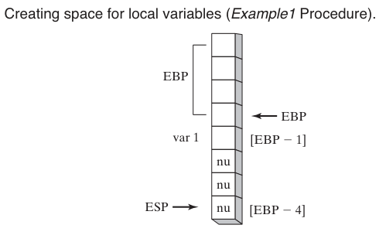

The nu blocks represent unused bytes. The following diagram shows how the stack looks after the Example2 procedure has been compiled and assembled:

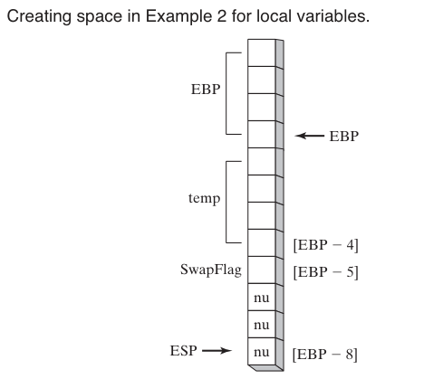

The temp variable is a doubleword variable, so it is aligned on a doubleword boundary.

The SwapFlag variable is a byte variable, but it is still allocated four bytes of space on the stack because the stack is aligned on a doubleword boundary.

***Stack size for nested procedure calls***

The stack size required for nested procedure calls is the sum of the stack sizes required for each individual procedure call.

This is because the stack is used to store the local variables and return addresses for all active procedure calls.

For example, in the following code:

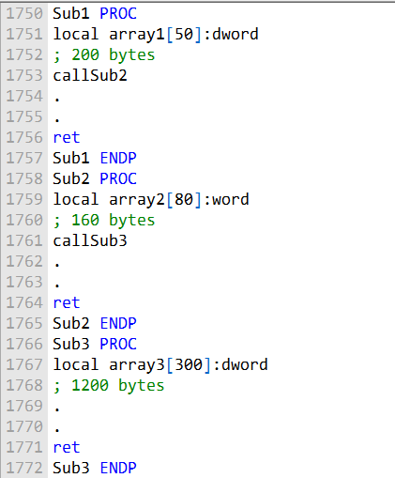

The stack size required for Sub1 is 200 bytes, the stack size required for Sub2 is 160 bytes, and the stack size required for Sub3 is 1200 bytes. Therefore, the total stack size required for this code is 1560 bytes.

This stack size is the minimum amount of stack space that must be available in order for this code to execute correctly. If there is not enough stack space available, the program will crash.

Recursive procedure calls

If a procedure is **called recursively**, the stack space it uses will be approximately the size of its local variables and parameters multiplied by the estimated depth of the recursion.

For example, if a procedure has 100 bytes of local variables and parameters, and it is called recursively to a depth of 10, then the procedure will use approximately 1000 bytes of stack space.

***Stack overflow***

If the stack space required for a program exceeds the amount of stack space available, the program will crash. This is called a **stack overflow.**

To avoid stack overflows, it is important to be aware of the s**tack space requirements of your program.** You can use the **STACK directive** to reserve additional stack space if necessary.

The stack size required for nested procedure calls is the sum of the stack sizes required for each individual procedure call.

If a procedure is called recursively, the stack space it uses will be approximately the size of its local variables and parameters multiplied by the estimated depth of the recursion.

To avoid stack overflows, it is important to be aware of the stack space requirements of your program and to reserve additional stack space, if necessary.

***Here is a summary of the key points from the chapter:***

* There are two types of procedure parameters: register parameters (faster, used by Irvine libraries) and stack parameters (more flexible).
* A stack frame is the region of stack used by a procedure for its parameters, local variables, saved registers, and return address.
* Parameters can be passed by value (copied) or by reference (address passed). Arrays should be passed by reference.
* Stack parameters are accessed using EBP offset addressing like [EBP-8]. LEA is good for getting stack parameter addresses.
* ENTER/LEAVE instructions manage the stack frame set up/teardown.
* Recursive procedures call themselves directly or indirectly. Recursion works well with repeating data structures.
* Local variables have restricted scope, lifetime tied to the procedure, don't cause naming clashes, and enable recursion.
* INVOKE directive calls procedures with multiple arguments. ADDR passes pointers.
* PROC declares procedures, PROTO prototypes existing procedures.
* Large programs should be split into multiple source code modules for manageability.
* Java bytecode is the machine language in compiled Java programs. The JVM executes it. Bytecodes use a stack-oriented model.